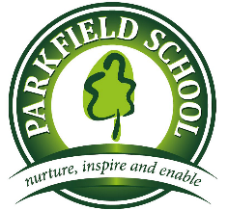 | Year 2  Wrens & Owls  Spring Term 1 Newsletter | 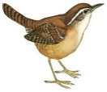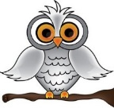

Literacy:  We will be writing a narrative based on The Kapok Tree. We will also be looking at using inverted commas in our writing.  Non-Fiction Booklets  We will be producing information booklets about the Amazon and rainforests around the world. | Numeracy:  - Place Value  - 2D and 3D Properties of shape – tessellation and right angles  - Fractions  - Multiplication 2, 5 & 10  - Division  - Money – counting and giving change  - Data collecting and sorting – Carroll and Venn Diagrams  Please help by: Practising counting money with real coins and giving change.
Our Topic theme this half term is:  ‘Amazing Amazon!’  We will be looking at the Amazon rainforest and different rainforests all over the world. We will research the environment, plants and wildlife that inhabit those regions.  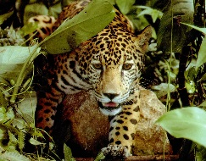  If you have any books or interesting photos/objects/stories to tell, then please bring them in to share! | PSHE, Citizenship & other learning:  We will be continuing to promote the Parkfield Promises and how to be a ‘good friend’.  We will be looking at New Year’s resolutions and what these mean, as well as understanding Chinese New Year.
What we enjoyed last term:  - Our Winchester Science Park trip was a great success and children loved the planetarium and asked some very interesting and complicated questions!  - They enjoyed preparing for their performance of The Nativity and sang the songs with great enthusiasm!  - Our Armed Forces careers visitor was a great success and the children loved finding out about the various planes and aircraft. | Other Info and Things to remember:  - Owls have P.E. on Wednesday afternoon  - Wrens have P.E. on Tuesday afternoon  - We endeavour to change home reading books as often as possible so please bring them in every day, regardless if they have been read with so we can use them here at school.  - Homework – We give homework out on a Wednesday which is to be returned by Monday.  - Please name their uniform! We endeavour to do what we can to hold onto their belongings but we do have a large site! All things named will find their owner.

