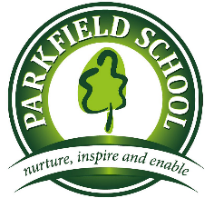 | Year 1 Bees  Spring Term 1 Newsletter | 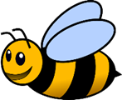

Literacy:  We will have our own ‘dinosaur hunt!’ and write a report about what we saw.  We will also be writing instructions about how we make sandwiches and salt dough.  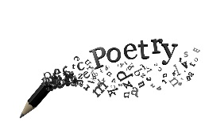  Lastly, we will be introducing poetry. We will read poems and perform them. | Numeracy:  - Time  - Addition – word problems.  - Subtraction – word problems.  - Counting and ordering numbers up to 100 – forwards and backwards.  - Coins and money. We will introduce problem solving.  Please help by:  Practising counting forwards and backwards. Practising recognising numbers up to 100. Recognising and naming coins and role playing. Ask the time or read the time to them whenever there is an opportunity.
Topic:  Our Topic theme this half term is: ‘Prehistoric World’  We will be looking at dinosaurs and fossils. We will look at what they ate and how they survived. We will paintand make sculptures.  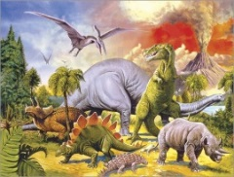  If you have any books or interesting photos/objects/stories to tell, please bring them in to share with the class! | PSHE, Citizenship & other learning:  We will be continuing to promote the Parkfield Promises and how to be a ‘good friend’.  We will be looking at New Year’s resolutions and what these mean, as well as the Chinese New Year.
What Bees class have enjoyed!  - Our Space Dome experience was a great success and children loved the dome and asked some very interesting and complicated questions.  - They enjoyed preparing for their performance of the Nativity and singing Christmas carols and songs.  - French club LOVED baking their own ‘Pain au Chocolat!’ | Other info & things to remember:  - Bees have P.E. on Wednesday morning.  - We endeavour to change home reading books as often as possible so please bring them in every day, regardless if they have been read so we can use them here at school.  - Homework – We give homework out on a Wednesday which is to be returned by Monday.  - Please name their uniform, named things will find their owner!

