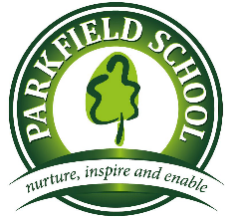 | Year 1 Bees  Summer Term 2 Newsletter | 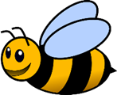

Literacy:  In Literacy we will be making up our own Traditional Tales with our own characters and setting. We will also be writing instructions on how to make salt-dough.  Grammar:  We will be focusing on grammar and looking at the following things:  - Punctuation - adding question marks (?) and exclamation marks (!)  - Using “and”- to link 2 sentences.  - Use comparative language -adding er and est. | Numeracy:  - Solve one step problems involving: sharing and adding equal groups using multiplication and division. Also using addition and subtraction to find missing numbers  - Applying understanding of money: finding totals, giving change and knowing the value of different denominations of coins and notes.  - Review directions, length and time.  Please help by:  Playing a shop keeper! Finding the price of two items and giving the right change. Looking at coins and notes and ordering them from the least to the most valuable. Draw a map of a town and then ask for and give directions. Pretend that there is a maze and listen to instructions such as; go forward, left, right, a quarter turn, half a turn to arrive at destination.
Topic:  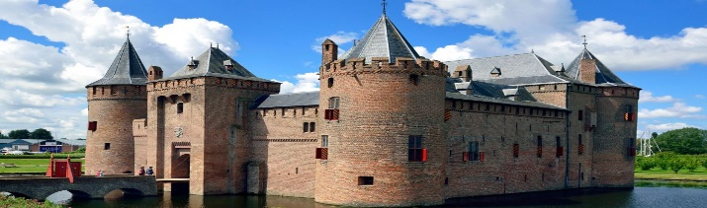  Our Topic theme this half term is: ‘Castles’.  In Science; we will be naming and comparing different materials.  In Art and Design; we will drew picture of a castle and then design our own. We will also be using different materials to make our own castle.  In Geography; we will be making our own maps and use our own symbols as a key. | PSHE, Citizenship & other learning:  We will be focusing on ‘the school community’, with a focus on how to keep safe in school.  We will be starting to look at classroom rules and class charters ready for Year 2.
What have we enjoyed:  - We have enjoyed the visit of a local author, who told us why she wrote her book and read it to us. We enjoyed making book marks and puppets of the guinea pigs from the story.  - The children particularly enjoyed making their own Arctic dioramas.  - We also enjoyed learning about animals, plants and writing fact files about them. | Other Info and Things to remember:  - Wednesday 19th June 2019 we will be going to Lulworth Castle!  - Please bring the form back and book it on wise pay. On the day don’t forget to bring a picnic and some healthy snacks with plenty of water. We don’t know what the weather will be like so be prepared to put some sun cream in the morning and bring a hat or get your wellies and raincoat on.  - During the holidays you can talk about what key features a castle has and why they have these.  - EYFS/KS1 SPORTS DAY Monday 24th June

