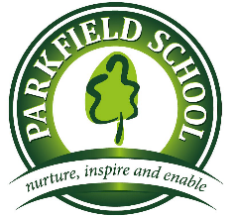 | Primary PE  Spring 1 Newsletter 2019

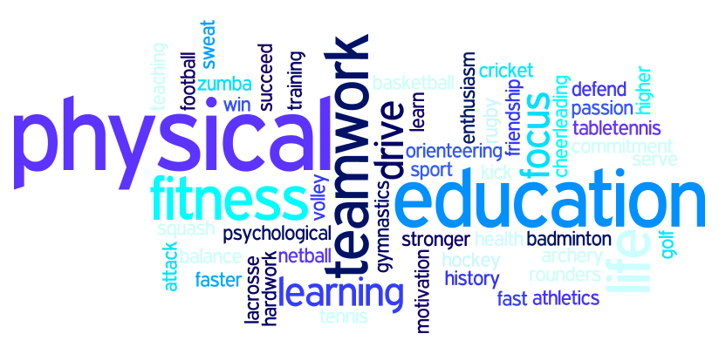

Key Stage 1 and 2 - Physical Education (core)
Please see below the sporting area we will be covering with each year group during this half term;

EYFS, Year 1 and 2
Students will be working on ball games. This will include the technique of how to throw and catch during game-based lessons.

Year 3 and 4
Students are introduced to ball games where they will focus on basketball. They will be learning the basic rules and techniques.

Year 5 and 6
Students will participate in Netball, basketball and various other ball-based games. They will be learning how to work as part of a team and different techniques within the activities.

Further Information
Students from Year 3, 4, 5 and 6 will have the opportunity to participate in Football, Netball, Swimming,
Tag- Rugby and multi skill tournaments with other schools in the Spring term.

All students (primary and secondary) also have the option of participating in lunchtime clubs delivered by BRS Coaching Academy throughout the week.

The lunchtime clubs will provide students an opportunity to try different sporting activities and also build positive relationships as well as their confidence.

The Wednesday lunch time dance club will also continue for Key Stage 2. This will allow students to learn and develop particular dance techniques.

