 | Autumn 1 | Autumn 2 | Spring 1 | Spring 2 | Summer 1 | Summer 2
KS3 | British Isles overview  Rivers  Field work  Highland Water | River Management  British Isles  Weather  Map skills | Ecosystems  Fantastic Places  North Pole | Natural Hazards  Tectonics  Tropical Storms | Globalisation  Development | Coral Reefs Project  Zombie Apocalypse (map skills!)  Micro climates, Litter, site EQAs
Year 9 | British Isles overview  Hazards Atmospheric  Tropical Storms  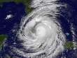  Flooding | Hazards Tectonic  Fieldtrip  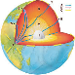  NHM | Ecosystems  TRF  Hot Desert | Ecosystems  Small Scale  Fieldwork Pond | Resource Management  UK | Resource Management  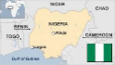  Global
Year 10 | UK Physical Landscapes  Rivers  Processes  Management  Somerset Levels  Fieldwork (practice data skills)  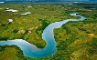  Highland Water | UK Physical Landscapes  Coasts  Management  Hard & Soft engineering  Physical Fieldwork  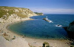  Barton on Sea | Hazards  Atmospheric  Climate Change  Maths skills  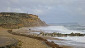 | Ecosystems  Small scale  Hot Desert  Hot Environments  Case study, Sahel  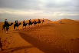 | Ecosystems  TRF  Resource Management Overview, UK  Food, Water, Energy  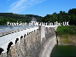 | Resource Management Global  Food// Water//Energy
Year 11 | UK Physical Landscapes  Coasts  Management  Hard & Soft engineering  Fieldwork Physical  Hengistbury Head  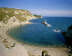  Maths Skills | UK Physical Landscapes  Rivers  Processes  Management  Somerset Levels | Resource Management Overview, UK  Food, Water, Energy  Resource Management Global  Food// Water//Energy | Urban Issues & Challenges  Fieldwork Human  Swanage  Pre release Paper 3 Focus  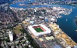 | AQA EXAM 2018  Unit 1  Tuesday 22nd May PM  Unit 2  Tuesday 5th June PM  Unit 3  Monday 11th June PM

