EYFS
Buttercups
Spring Term 2 Newsletter

Literacy:  We will be looking at non-fiction books to help us learn about life cycles. We will also be writing instructions on how to plant a seed. We will be retelling the story of Jack and the Beanstalk using story maps. We will be writing a recount about our trip to the farm.  Please help by: reading regularly, practising letter formation and working on reading and spelling ‘tricky’ words. | Numeracy:  - Ordering numbers  - Counting forwards and backwards to 20  - Adding and subtracting two single digit numbers  - 3D shapes  - Introducing time- looking at whole days, hours and half hours.  Please help by: practising counting 1-20. Using maths in real life contexts- what shapes can you see? Which is bigger/ smaller?
Topic: ‘Spring and Growth’  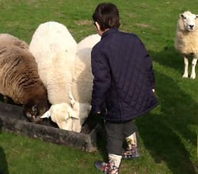  We will be looking at how plants grow including planting our own seeds, the life cycles of plants and animals and the Easter story. As part of our topic we will be visiting a farm. If you have any books or interesting photos/objects/stories to tell, then please bring them in to share! | PSHE, Citizenship & other learning:  Next term we are going to be looking at ‘feelings’ and reflecting on how our behaviour affects our friends and teachers.  Attendance  As a school we are having a big push on attendance. We understand that the children get ill and that we have had lots of nasty bugs going around this term. However, we would encourage you to bring your child to school and we will contact you if needed.
What we have enjoyed this term:  - The children have really enjoyed designing and making toys with junk modelling  - We had great fun being scientists- does how high a ramp affect how far a car will travel down a ramp  - We enjoyed learning about Chinese New Year too! | Other information and things to remember:  - Homework- please make sure this is completed and handed back to school every Monday!  - Parent’s evening- Wednesday 20th March and Thursday 21st March.  - Farm trip- Thursday 28th March  - Monday 25th February- INSET day  - We have a BOOK FAIR running from the Monday 4th March after school until Friday 8th March after school. It is run by ‘Book People’, further information is available on their website.

