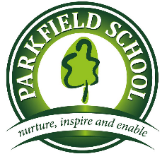 | EYFS  Buttercups  Spring Term 1 Newsletter

Literacy:  - Describing using adjectives  - Writing labels  - Rhyme  - Hold a sentence  - Write a sentence  - Read/ write tricky words  Please help by: reading regularly and practising letter formation | Numeracy:  - Counting backwards and forwards to 20  - Number bonds  - Place value  - Size  - Weight  - Capacity  Please help by: practising counting 1-20. Using maths in real life contexts e.g. counting blue cars
Topic:  Our theme this half term is ‘Toys’  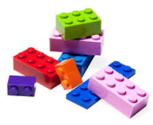  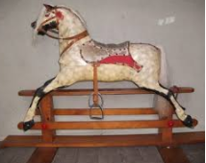  We will be looking at similarities and differences of toys from the past and present. How toys work/move and different technology. If you have any books or interesting photos/objects/stories to tell, then please bring them in to share! | PSHE, Citizenship & other learning:  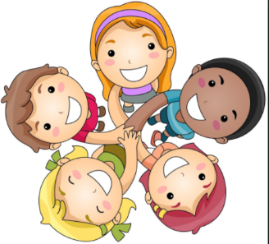  We will be continuing to work on being a good friend and how to follow the Parkfield Promises.  We will also be working on our outside play including group games, football, turn taking and having kind hands.
Other information:  We have had a very busy Autumn term learning about different festivals. We started the term with a trip to Waitrose, where we found out about bread and different types of fruit and vegetables.  The children worked very hard on their first nativity at school.  Have a lovely holiday and happy New Year!! | Things to remember:  - PE will be on a Friday morning  - We try our best to change home reading books every day. Please sign and comment when you have read the book.  - Homework is given out on a Wednesday and expected back in school the following Monday.  - Please name all items of clothing and belongings!

