Changing Economic World Page 22
Question | A B C
- Define development |  | A country improving. | The process of change for the better. | Making a change.
- Define development indicator |  | A measure of development | A country’s total development | A term to show development.
- List two development indicators that represent the quality of education. |  | Calorie intake & number of years in school | Literacy rate & number of years in school | Literacy rate & access to water
- List the four indicators that the UN uses in the Human Development Index (HDI) |  | Death rate, GDP, access to water and number of years in school | Literacy rate, GDP, life expectancy & number of years in school. | Literacy rate, GDP, life expectancy and calorie intake.
- Which indicator measure the total income of a country (including money earned overseas) |  | Gross Domestic Product | Human Development Index | Gross National Income
CAUSES OF THE DEVELOPMENT GAP
- What is the development gap? |  | The gap in development between the world’s richest and the world’s poorest nations. | The gap in development between the world’s richest and the world’s poorest people. | The gap in education between the world’s richest and the world’s poorest nations.
- List a social cause of the development gap. |  | Economy is worse in LICs | Education is worse in LICs | Other countries ruled LICs before they became independent.
- List an economic cause of the gap. |  | LICs sell cheap goods and buy expensive goods. | LICs sell expensive goods and buy cheap goods. | LICs sell cheap goods and buy cheap goods.
- List a physical cause of the gap. |  | Landlocked countries | Countries are too strong | There are rivers in between countries.
- How did colonialism affect the development gap? |  | After colonialism finished and countries gained independence, this was followed by a period of corruption and civil wars. | After colonialism finished and countries gained independence, many countries became landlocked. | After colonialism finished and countries gained independence, many countries wanted to go back to being ruled.
EFFECTS OF THE DEVELOPMENT GAP
- What is USA’s share of global wealth and what is Africa’s share of global wealth? |  | The USA has 35% of wealth.  Africa has 1% of wealth. | The USA has 30% of wealth.  Africa has 2% of wealth. | The USA has 1% of wealth.  Africa has 35% of wealth.
- How does development affect migration? |  | People want to leave LICs and move to HICs. | People want to leave HICs and move to LICs | People want to leave NEEs and move to LICs.
REDUCING THE DEVELOPMENT GAP
- What is aid and provide an example. |  | When one country receives help from another country  (Oxfam’s goat aid) | When one country receives help from another country (Fair trade schemes) | When one country receives help from another country  (microfinance loans)
- What is fair trade? |  | Companies get a fair price for the crops they grow | Farmers get a lower price for the crops they grow. | Farmers get a fair price for the crops they grow.
- Suggest one way fair trade helps people in LICs and NEEs. |  | Farmers receive a fair price for the goods they produce, then they can invest money in the local economy. | Farmers receive a fair price for the goods they produce, then they can invest money in transnational communities. | Farmers receive an unfair price for the goods they produce, then they can invest money in the local economy.
- Who might provide investment? |  | Oxfam’s Goat Aid | International Monetary Fund | Transnational corporations.
- Suggest one way investment could help people in LICs and NEEs. |  | People have better access to employment. | Famers are paid more. | People have better access to water.
- What is a microfinance loan? |  | A very small loan given to people in LICs to start up small businesses. | A big loan given to people in LICs to help support the economy. | A small loan given in people in HICs to help develop aid projects in LICs
- Suggest one example of a microfinance loan programme in an LIC or NEE. |  | Grameen Bank provide small loans of 4100 to develop small businesses. | International Monetary Fund cancelled the debt of 19 of the poorest LICs. | Oxfam’s goat aid gave families goats, that provide milk, meat & income.
- What is debt relief? |  | HICs reduce the amount of money LICs and NEEs have to pay back. | LICs reduce the amount of money in LICs and NEEs have to pay back. | HICs owe LICs more money, this doesn’t need to be paid back.
- Suggest one example of how debt relief has been used to help LICs or NEEs develop. |  | International Monetary Fund cancelled the debt of 29 of the poorest LICs. | International Monetary Fund cancelled the debt of 19 of the poorest LICs. | International Monetary Fund cancelled the debt of 39 of the poorest LICs.
- Identify a country that uses tourism to develop. |  | Nigeria | Jamaica | UK
- Suggest one positive and one negative impact tourism had on the host country. |  | Improved healthcare  Increased amount of Pollution | Improved healthcare  Improved education | Improved healthcare  Reduced pollution
- What is a population pyramid? |  | A population pyramid shows the number of men and women living in a country. | A population pyramid shows the number of children living in s country. | A population pyramid shows the number of men living in s country.
- Do LICs or HICs have a wide base? Why? |  | LICs have a wide base because there are is a low birth rate. | LICs have a wide base because there is a high birth rate. | HICs have a wide base because there is a high birth rate.
- Do LICs or HICs have wide bars at the top of the pyramid? Why? |  | HICs have wide bars at the top because they have a high life expectancy. | HICs have wide bars at the top because they have a low life expectancy. | LICs have wide bars at the top because they have a high life expectancy.
- What happens to the width of the bars in a LIC population pyramid? |  | The width of the bars gets smaller due to the high death rate. | The width of the bars gets smaller due to the low death rate. | The width of the bars gets larger due to the high death rate.
- How many stages are there in the Demographic Transition Model? |  | 3 | 5 | 4
- Why does death rate fall in stage 2? |  | Lack of birth control | Improved medical care | Increase in status of women
- Why does birth rate fall in stage 3? |  | Improved medical care | Women are educated longer | Lack of birth control
- Suggest why birth rate begins to fall again in stage 5? |  | Women have fewer children. | Lack of birth control | Improved medical care

Changing Economic World Page 22
Question
- Define development
- Define development indicator
- List two development indicators that represent the quality of education.
- List two development indicators that represent quality of healthcare
- List the four indicators that the UN uses in the Human Development Index (HDI)
- Which indicator measure the total income of a country (including money earned overseas)
CAUSES OF THE DEVELOPMENT GAP
- What is the development gap?
- List a social cause of the development gap.
- List an economic cause of the gap.
- List a physical cause of the gap.
- How did colonialism affect the development gap?
EFFECTS OF THE DEVELOPMENT GAP
- Differential wealth is an effect of the gap. What is USA’s share of global wealth and what is Africa’s share of global wealth?
- How does development affect migration?
REDUCING THE DEVELOPMENT GAP
- What is aid and provide an example.
- What is fair trade?
- Suggest one way fair trade helps people in LICs and NEEs.
- Who might provide investment?
- Suggest one way investment could help people in LICs and NEEs.
- What is a microfinance loan?
- Suggest one example of a microfinance loan programme in an LIC or NEE.
- What is debt relief?
- Suggest one example of how debt relief has been used to help LICs or NEEs develop.
- Identify a country that has use tourism to develop.
- Suggest one positive and one negative impact tourism had on the host country.
- What is a population pyramid?
- Do LICs or HICs have a wide base? Why?
- Do LICs or HICs have wide bars at the top of the pyramid? Why?
- What happens to the width of the bars in a LIC population pyramid?
- How many stages are there in the Demographic Transition Model?
- Why does death rate fall in stage 2?
- Why does birth rate fall in stage 3?
- Suggest why birth rate begins to fall again in stage 5?

THE CHANGING ECONOMIC WORLD PART 1 (page 22)

Study Figure 1, a world map showing the global distribution of Human Development Index (HBI) values.
- Name the four indicators that are using to produce the Human Development Index (HDI) value. 2 marks)
- Suggest why HDI might be a better indication of a country’s level of development than GNP. (4 marks)
- Using the figure, compare HDI values in Africa and South America. (2 marks)

Study Figure 2a, a scattergraph showing the link between life expectancy and the percentage of the population with access to safe water supply. Describe how improvements in the quality and quantity of water can change people’s lives. (4 marks)

Study Figure 2b, a scattergraph showing the link between GNP per head and the percentage of people employed in agriculture in selected countries.
- What does GNP mean? (1 mark)
- What is the relationship between GNP per head and the percentage of people employed in agriculture shown in the scattergraph? (1 mark)

Explain two reasons why poorer countries earn less money from trade than richer countries. (4 marks)

Using a named example to show the impact of a natural hazard on a country’s development. (4 marks)

Describe the social causes of the development gap. (3 marks)

Study Figure 3, population pyramids of two different countries.
- Which age group has the highest percentage in Pyramid A? (1 mark)
- What percentage of the population are females, aged between 10 and 14 years of age in pyramid B? (1 mark)
- Compare the shapes of the two pyramids. (4 marks)
- Explain how these population pyramids suggest that these coutnries are in different stages of the Demographic Transition Model (4 marks)
- Give two ways that population structure changes when a country has entered Stage 5 of the DTM. (2 marks)
- Which pyramid shows an LIC? (1 mark)
- Give one reason for your answer. (2 marks)

Study Figure 4, a pie chart showing the imports and exports of one country.
- Name the type of goods that were the biggest percentage of the country’s imports. (1 mark)
- What percentage of this country’s imports was petrol and refined oil products: 10, 20 or 30? (1 mark)
- Give two reasons why this country is likely to be an LIC. (2 marks)
- Explain how trade could be made more favourable for LICs. (4 marks)

Choose one of the following measures of development: birth rate, literacy rate or GNP.
- Explain why it gives a good indication of a country’s development (2 marks)
- Explain why it is a disadvantage to use only one measure of a country’s development. (4 marks)
- Death rates are sometimes used as a measure of development. Explain why death rates may not be a good measure of the difference in development between HICs and LICs. (2 marks)

There are various measures of development.
- choose one measure of development and explain its advantages as a measure of development. (3 marks)
- Choose one measure of development and explain its disadvantages as a measure of development. (3 marks)

What is the meaning of the term birth rate? (2 marks)
In India, the birth rate is 30 (per 1000 people) and the death rate is 11 (per 1000 people). What is India’s natural increase value? (1 mark)

Study Figure 5, a graph showing the changes in the share of world manufacturing industry in three types of country (MEDC = HIC, LEDC = LIC and NIC = NEE)
- What share of the world’s manufacturing industry was found in HICs in 1985? (1 mark)
- What does the graph show about the changing share of manufacturing industry in the world? (2 marks)
- Describe and explain the difference between the employment structures of HICs and LICs. (6 marks)

Study Figure 6, a diagram showing some effects of developing tourism in tropical areas. Add one correct letter to each empty box to complete the diagram. Choose the letter from the list below. Each letter should be used once.
Fairtrade and Trading Groups are ways in which poor countries can get a better deal from world trade.
- What is a trading group?
- Outline one way in which trading groups can help poor countries get a better deal from world trade.
- Are the following statements about Fairtrade and Trading Groups true or false?

Outline one way that Fairtrade helps to deal with the problems of unequal development (2 marks)
Suggest one reason why Fairtrade schemes are not always successful. (2 marks)

Study Figure 7, a photograph taken in Hawaii, a tropical tourist destination.
- Outline how Figure 7 shows the way in which the negative effect of tourism is being managed. (2 marks)
- Use Figure 7 and your own knowledge to describe how the negative effects of tourism can be reduced. (4 marks)

Study Figure 8, showing information about Romania, a member of the EU.
- What is the temperature in Bucharest in February? (1 mark)
- Estimate how much of Romania is highland: 30%, 60% or 90%? (1 mark)
- Outline one way physical factors may affect the development of a country, such as Romania. (2 marks)
- Give two human factors, which may explain why an EU country such as Romania is less developed than the UK. (2 marks)
- Describe how the EU tries to reduce differences in the levels of development within Europe. (4 marks)

Study Figure 9, showing tourist arrivals to the islands of the Caribbean.
- Give two facts about tourist arrivals to the islands of the Caribbean. (2 marks)
- Suggest two reasons why people would visit Jamaica. (2 marks)
- Use a case study to explain how tourism has impact on the host country. (8 marks)

Using an example, assess the impact tourism has on poorer countries. (9 marks)

In 2000, a 15-year plan was introduced to develop tourism in an unspoilt coastal area of Bahia, in eastern Brazil. Study Figure 10, which includes a newspaper article about the area, and gives different views about the development.
- Do you think it was a good idea to develop the Bahia coast in Brazil: yes or no?
- Explain your decision. Use Figure 10 and your own knowledge. (9 marks)

Cadbury is a TNC that makes chocolate in the UK using cocoa that is grown in Ghana. Cadbury has tried to help reduce the development gap between Ghana and the UK. In Figure 11, a manager outlines some actions that Cadbury has taken in Ghana.
- What is meant by fair trade? (2 marks)
- Explain how the actions taken by Cadbury could help to improve the standards of living for people in Ghana. (6 marks)

Figure 12, shows Lisu Lodge, an ecotourism development in rural Thailand.
- Describe how the figure suggest the Lisu Lodge is an ecotourism development. (4 marks)
- Explain how ecotourism developments are managed in a sustainable way. (4 marks)

Figure 13, shows information about Dubai, a coastal area in the United Arab Emirates.
- In which part of the world is the United Arab Emirates: Western Europe, Middle East or South East Asia? (1 mark)
- Describe how the number of visitors to Dubai changed between 1990 and 2010. (2 marks)
- Give two physical factors that might attract tourists to Dubai. Use the figure. (2 marks)
- A new international airport is being built. Suggest two reasons why. (2 marks)
- Explain how coastal areas provide opportunities for economic development. Use the figure and your own knowledge. (6 marks)

Study the text box in Figure 14, an extract from a website about a microfinance programme in Africa. Use the extract and your own knowledge to explain how people in the poorer part of the world can attempt to improve their own quality of life. (4 marks)

Figure 3
Figure 1
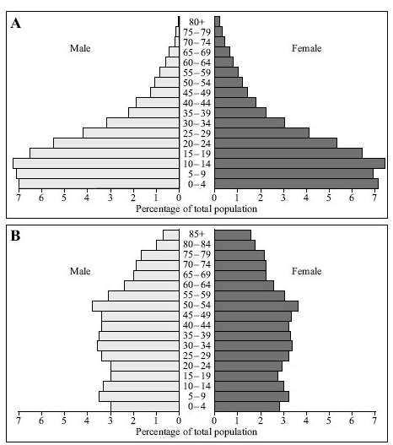

Figure 2a

Figure 4
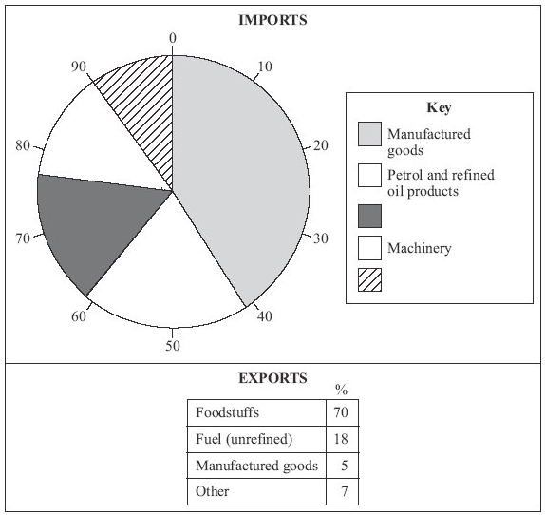

Figure 2b

Figure 5
Figure 6

Figure 9
Figure 7

Figure 8

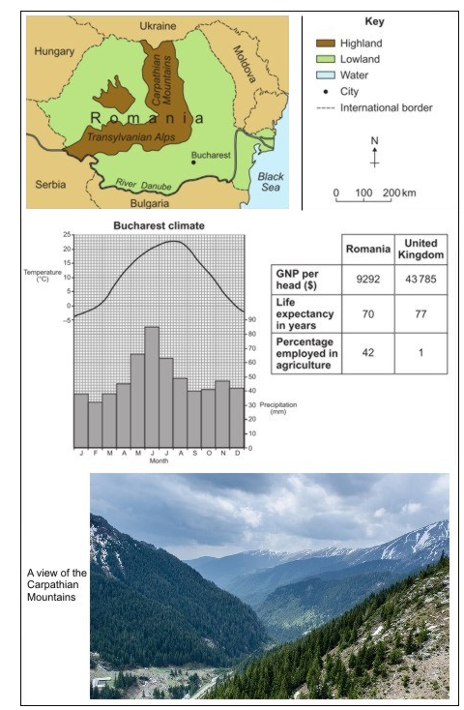
Figure 10

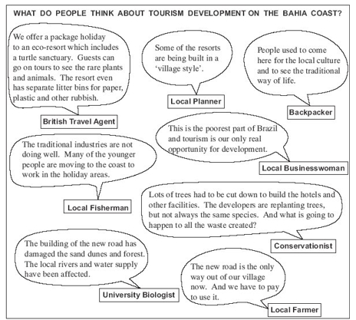
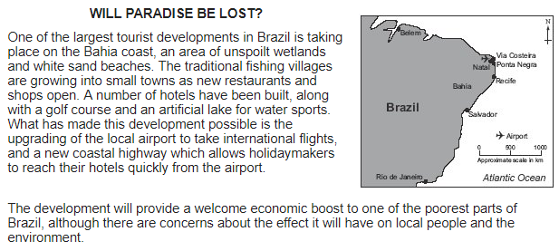

Figure 11

Figure 12
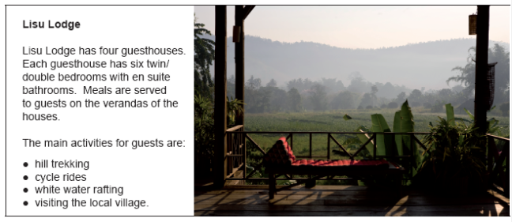

Figure 13
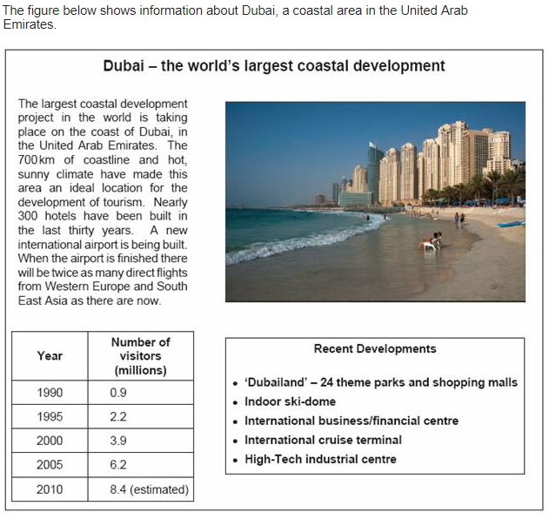

Figure 14

Changing Economic World Page 23
Question | A B C
- Define NEE |  | New economic emergent | Nearly emerging economy | Newly emerging economy
- Where is Nigeria located? |  | Just north of the equator in west Africa. | Just north of the equator in east Africa. | Just north of the equator in north Africa.
- List one reason Nigeria is locally important |  | It has the fastest growing economy in Africa. | It has the 3rd fastest growing economy in Africa. | In 2014 it had the 3rd highest GDP in Africa.
- List one reason Nigeria is globally important |  | It supplies 3% of the world’s oil. | It supplies 2.7% of the world’s oil. | It supplies 7.2% of the world’s oil.
- When did Nigeria gain independence? |  | 1960 | 1966 | 1970
- Between 1960-1970 Nigeria suffered from.. |  | Famine | Civil wars | Malaria epidemic
- Since 1999 Nigeria has had a…… |  | Civil wars | Stable government | Famine
- Identify two ethnic groups in Nigeria. |  | Yoruba and Islam | Igbo and Christianity | Yoruba and Igbo
- Identify two religious groups in Nigeria. |  | Christianity and Islam | Yoruba and Igbo | Igbo and Christianity
- List two of Nigeria’s political links. |  | ECOWAS and United Nations | African Union and India | African Union and United Nations
- What are Nigeria’s two main exports? |  | Crude oil and cars | Crude oil and telephones | Crude oil and agricultural products
- List two countries Nigeria trades with. |  | India and China | India and Sweden | China and France
- In 1999 people were mainly employed in… |  | The primary sector | The secondary sector | The tertiary sector
- In 2012 there are equal people employed in… |  | Primary & secondary sectors | Secondary, tertiary & quaternary sectors | Primary, secondary & tertiary sectors
- Why were people pushed from agriculture? |  | Bad pay | More machinery | Good working conditions in factories.
- What attracted people to factories and services? |  | More machinery | Bad pay | Better pay and working conditions
- Why were there more jobs available in factories? |  | Unstable government = more TNCs opened factories in Nigeria. | Stable government = less TNCs opened factories in Nigeria. | Stable government = more TNCs opened factories in Nigeria.
- Why were there more jobs available in services? |  | People moved away from the factories | Improved trade links | Bad pay
- What is the multiplier effect? |  | When wages are multiplied to help other people. | Jobs multiplied by other jobs | The knock on benefits of a rise in the manufacturing sector
- Suggest one example of the multiplier effect. |  | Higher incomes mean people spend less money. | More disposable income is spent in the local community = local economy improves. | High income = less taxes to the government = more development.
- What is a Transnational Corporation? |  | A company that operates in several different countries. | A company that operates in only one country. | A country that has different companies in it.
- How many TNCs operate in Nigeria? |  | 34 | 40 | 44
- Why do companies decide to globalise? |  | Wages are cheaper in LICs and NEEs. | It is nice to work in different countries | They can work with different governments
- Shell oil drills oil in the……… |  | North sea | Niger delta | Nigerian ocean
- When did they start to drill oil? |  | 1958 | 1968 | 1988
- When is Shell Oil’s headquarters? |  | Belgium | Netherlands | France
- Identify an economic advantage to Nigeria. |  | Shell provides 65,000 jobs. | Shell improve local infrastructure (roads and buildings) | Profits generated go overseas.
- Identify a social advantage to Nigeria. |  | Shell provides 65,000 jobs. | Shell improve local infrastructure (roads and buildings) | Profits generated go overseas
- How have Shell Oil developed the local area? |  | Shell provides 65,000 jobs. | Shell improve local infrastructure (roads and buildings) | Profits generated go overseas
- Identify a social disadvantage to Nigeria. |  | Oil spills and water pollution | Local workers are poorly paid | Profits generated go overseas
- Identify an environmental disadvantage. |  | Oil theft is a big problem. | Oil spills and water pollution | Local workers are poorly paid
- Identify an economic disadvantage |  | Oil spills and water pollution | Local workers are poorly paid | Profits generated go overseas

Changing Economic World Page 23
Question
- Define NEE
- Where is Nigeria located?
- List one reason Nigeria is locally important
- List one reason Nigeria is globally important
- When did Nigeria gain independence?
- Between 1960-1970 Nigeria suffered from..
- Since 1999 Nigeria has had a……
- Identify two ethnic groups in Nigeria.
- Identify two religious groups in Nigeria.
- List two of Nigeria’s political links.
- What are Nigeria’s two main exports?
- List two countries Nigeria trades with.
- In 1999 people were mainly employed in…
- In 2012 there are equal people employed in…
- Why were people pushed from agriculture?
- What attracted people to factories and services?
- Why were there more jobs available in factories?
- Why were there more jobs available in services?
- What is the multiplier effect?
- Suggest one example of the multiplier effect.
- What is a Transnational Corporation?
- How many TNCs operate in Nigeria?
- Why do companies decide to globalise?
- Shell oil drills oil in the………
- When did they start to drill oil?
- When is Shell Oil’s headquarters?
- Identify an economic advantage to Nigeria.
- Identify a social advantage to Nigeria.
- How have Shell Oil developed the local area?
- Identify a social disadvantage to Nigeria.
- Identify an environmental disadvantage.
- Identify an economic disadvantage

THE CHANGING ECONOMIC WORLD PART 2 (page 23)

Many call centres have moved from the UK to India.
- What sector of the economy includes call centres: secondary, tertiary or primary?
- Study Figure 1, statements about why call centres have developed in India. For each statement, identify whether the reason is social, economic or political. (3 marks)
- Choose one of the statements from Figure 1 and outline how it has led to the growth of call centres in India. (2 marks)
- Explain how developments in ICT have encouraged globalisation. (4 marks)
- Apart from developments in ICT, outline one or more economic reasons for the growth of call centres abroad, (3 marks)

Study Figure 2, a graph that shows how the share of world manufacturing production has changed between 1970 and 2010.
- What percentage of the world’s manufacturing production did the rich world produce in 1970? (1 mark)
- What was the increase in East Asia’s share of world manufacturing production between 1970 and 2010? (1 mark)
- Describe the changes that have happened between 1970 and 2010. (3 marks)
- The growth of manufacturing in East Asia is because of several factors including: government legislation, long working hours, health and safety regulations and prohibition of strikes. Explain how one or more of these factors was important for the growth of manufacturing industry in parts of the poor world such as East Asia. (4 marks)

What is the meaning of the letters TNC? (1 mark)
Describe the features of a named TNC. (6 marks)
Use a case study to describe the advantages and disadvantages of the development of a TNC. (9 marks)

Intel is planning to build a new chip assembly and testing factory in China.
- China is a good place for a TNC to build a new factory. Suggest two reasons why. (2 marks)
- A new factory might benefit the area in which it is built. Describe some of the benefits. (6 marks)

Study Figure 3, which shows recent industrial growth in China. Use Figure 3 and your own knowledge to explain the growth of industry in modern China. (6 marks)

Describe the benefits of industrial growth in an economically developing area you have studied. Use an example(s) that you have studied. (6 marks)

Transnational corporations (TNCs) only bring advantages to the host country.
- Do you agree with this statement: yes or no?
- Justify your decision. (9 marks)

Describe the local importance of a LIC or NEE that you have studied. (3 marks)
Describe the global importance of a LIC or NEE that you have studied. (3 marks)

Using a named example, describe how development in trade links has helped them develop. (4 marks)

Using a case study of a LIC or NEE, describe and explain how their economy has changed. (6 marks)

Figure 1

Figure 2

Figure 3
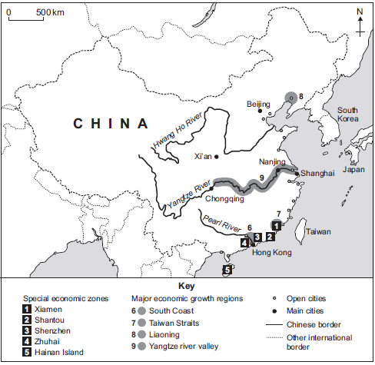

Changing Economic World Page 24
Question | A B C
- Define aid | Support needed to a country that doesn’t need it | Support given to a country in need. | Support given when someone has an accident
- List two types of aid. | Emergency aid and development aid. | First aid and development aid | Primary aid and emergency aid.
- Suggest one reason why Nigeria needs aid. | 100 Nigerians (60%) live on less than $1/day | 100 million Nigerians (60%) live on less than $1/day | 100 million Nigerians (60%) live on less than £5/day
- How much monetary aid did Nigeria receive in 2013? | $500 million | $5000 million | $5500 million
- How does Nets for Life help Nigerians? | Education and malaria prevention. | Education and fishing | Improved access to food.
- How does the USA help Nigerians? | Education about AIDs. | Education about malaria. | Education and water supply
- How did the World Bank support Nigeria in 2014? | Provided $5000 million for long-term loans to business. | Provided $500 million for long-term loans to business. | Provided $50 million for long-term loans to business.
- What is the Aduwan Centre? | Food bank | Shopping centre | Health clinic
- What two organisations helped create the Aduwan Centre? | ActionAid and World Bank | ActionAid and the EU | World bank and IMF
- How does the Aduwan Centre support Nigerians? | Provides childcare, educates women and tests for HIV. | Provides vaccinations, educates women and tests for HIV. | Provides vaccinations, educates men and tests for HIV.
ENVIRONMENTAL IMPACTS OF DEVELOPMENT
- What is industrial growth? | Large scale farming to make a profit. | Increase in factories and industrial plants | Growth of urban areas.
- How has it affected Nigeria’s environment? | Increase in air pollution in cities such as Nairobi. | Increase in air pollution in cities such as Lagos. | Increase in air pollution in cities such as Cairo.
- What is urban growth? | Large scale farming to make a profit. | Increase in factories and industrial plants | Growth of urban areas.
- How has it caused issues in Nigeria? | Lack of services and housing | Too many industries | Oil spills, such as the Bodo Oil spill.
- Where does oil extraction occur? | Niger delta | River Nile | Niger river
- What happened in 2008/9? | Explosion of power station. | Bodo Oil Spill | Creation of a new squatter settlement.
- What two industries were affected? | Oil producers and famers | Fishermen and local shops | Agriculture: Farmers and fisherman
- How did Shell compensate the victims? | £55million | £50million | £5million
- What is commercial farming? | Large scale farming to make a profit. | Increase in factories and industrial plants | Growth of urban areas.
- How has it affected Nigeria’s environment? choose two. | 70-80% of Nigeria’s forests have been deforested. | Farming has given people jobs | Farming has caused ground and water pollution.
POSITIVE IMPACTS OF DEVELOPMENT
- Suggest two services that have been improved due to Nigeria’s development. | Better access to clean water | Improved healthcare (more doctors and hospitals) | Improved animal care with more vets.
- List one reason why families have more disposable income. | More people work in primary sector | Higher wages in secondary and tertiary industries. | Lower wages in secondary and tertiary industries.
- How will increased incomes benefit Nigerian families?  - Which of the following are correct? | Better healthcare | Better housing | Better road networks
- How did their HDI change between 2000 – 2011. | HDI improved by 50% | HDI improved by 30% | Highest HDI improvements
HOW TO OVERCOME REMAINING ISSUES
- Identify the three main priorities for Nigeria in order for them to develop further. | Stable government  Peace among religious groups  Environmental sanctions | Stable government  Better transport links  Environmental sanctions | Stable government  Peace among religious groups  Improved access to water

Changing Economic World Page 24
Question
- Define aid
- List two types of aid.
- Suggest one reason why Nigeria needs aid.
- How much monetary aid did Nigeria receive in 2013?
- How does Nets for Life help Nigerians?
- How does the USA help Nigerians?
- How did the World Bank support Nigeria in 2014?
- What is the Aduwan Centre?
- What two organisations helped create the Aduwan Centre?
- How does the Aduwan Centre support Nigerians?
ENVIRONMENTAL IMPACTS OF DEVELOPMENT
- What is industrial growth?
- How has it affected Nigeria’s environment?
- What is urban growth?
- How has it caused issues in Nigeria?
- Where does oil extraction occur?
- What happened in 2008/9?
- What two industries were affected?
- How did Shell compensate the victims?
- What is commercial farming?
- How has it affected Nigeria’s environment?
POSITIVE IMPACTS OF DEVELOPMENT
- Suggest two services that have been improved due to Nigeria’s development.
- List one reason why families have more disposable income.
- How will increased incomes benefit Nigerian families?
- How did their HDI change between 2000 – 2011.
HOW TO OVERCOME REMAINING ISSUES
- Identify the three main priorities for Nigeria in order for them to develop further.

THE CHANGING ECONOMIC WORLD PART 3 (page 24)

Describe one or more advantages of aid. (3 marks)
Suggest one disadvantage of aid. (2 marks)

Study Figure 1, a photograph of people building a sea dyke in Vietnam. Oxfam provided aid for this project. Use the figure above and your own knowledge to show how international aid can encourage sustainable development. (6 marks)

Use an example to describe the main features of an aid project and the impact it had on the area. (6 marks)

Study Figure 2, a map showing the top five recipients of aid from the UK Government in 2010.
- Use the following information to complete the figure: Aid from UK to Bangladesh: £150 million. (1 mark)
- Suggest some advantages of the UK of donating aid. (3 marks)

Aid to poor countries can be given in different ways. Explain why a reduction in debt repayments can have advantages for LICs. (4 marks)

Study Figure 3, a cartoon about aid.
- Name the type of aid being talked about in the cartoon. (1 mark)
- Why is this type of aid an advantage to HICs? (2 marks)
- Give one disadvantage of aid being given LICs. (1 mark)

Use a case study to describe how rapid economic development can affect the environment. (9 marks)

Describe the effects of air pollution and water pollution in urban areas in poorer parts of the world. (6 marks)

To what extent has economic development benefitted a LIC or NEE that you have studied. (9 marks)

Figure 1
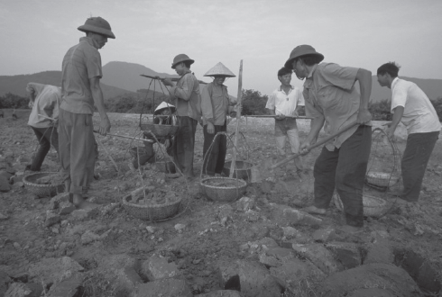
Figure 2
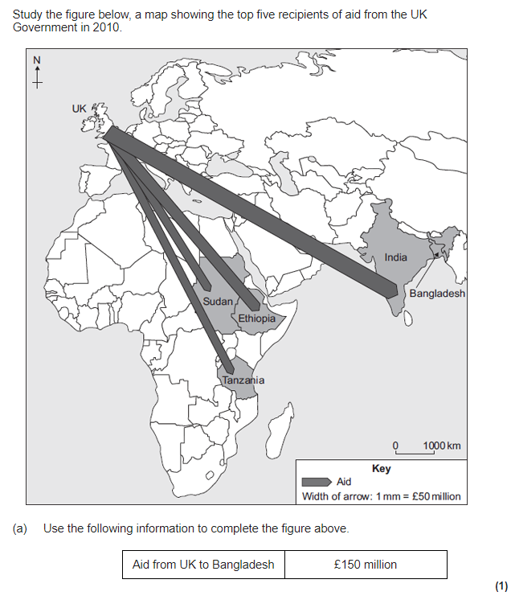

Figure 3
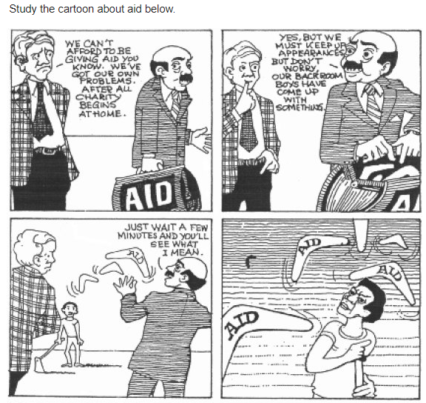

Changing Economic World Page 25
Question | A B C
- List two types of tertiary job |  | Finance, teacher | Farmer, teacher | Researcher, farmer
- What is industrialisation? |  | Rise in farming | Rise in quaternary sectors | Rise in manufacturing
- When did it occur in the UK? |  | Late 18th century | Late 19th century | Late 17th century
- What is de-industrialisation? |  | Decline in manufacturing industries | Decline in manufactured goods | Decline in car manufacture
- When did it occur in the UK? |  | Late 2000s | Late 1900s | Late 1800s
- What type of economy was created following de-industrialisation? |  | Post manufacture economy | After industry economy | Post-industrial economy
- How did the increase in manufacturing in LICs and NIEEs cause de-industrialisation? |  | Goods were manufactured in the UK | Goods were manufactured abroad | Manufactured goods were sold abroad
- How did improvements in communications cause de-industrialisation? |  | It was easier to trade with other countries | It was harder to trade with other countries | --
- What is UK’s main economic sector? |  | Tertiary sector | Primary sector | Secondary sector
- How much does the main economic sector contribute to the UK’s GDP? |  | 97% | 79% | 77%
- What industries are in the quaternary sector? |  | Manufacturing | High tech and IT | Services
- How much does the quaternary sector contribute to the UK’s GPD? |  | £3 billion | £10 billion | £5 billion
- What is a science park? |  | A site on which low- tech industries carry out scientific research. | A site on which high- tech industries carry out medical research. | A site on which high- tech industries carry out scientific research.
- Why are science parks often located near universities? |  | They have access to university sports facilities | They have access to highly skilled graduates | They have access to lots of students
- What other factors affect where a science park is located? |  | High house prices | Good transport links | Bad transport links
- What is one advantage of Cambridge Science Park’s location? |  | Close to Stansted airport and M11. | High city centre house prices. | Lack of entertainment options.
- What is one disadvantage of Cambridge Science Park’s location? |  | Close to Stansted airport and M11. | High city centre house prices. | Lack of entertainment options.
- What percentage of people in the UK live in rural areas? |  | 9% | 19% | 20%
- What process leads to the increase in rural populations? |  | Counter-urbanisation | Counting-urbanisation | Counter-urban movement
- What is one advantage of population growth in rural areas? |  | Local businesses grow | Good transport links | Congestion
- What is one disadvantage of population growth in rural areas? |  | Good transport links | Congestion | Local businesses decline
- What process leads to the decrease in rural populations? |  | People move because they don’t like the countryside | People move to find better employment | People move to follow their friends
- Has the Outer Hebrides experienced population growth or decline? |  | Population growth | Population has stayed the same | Population decline
- Has South Cambridge experienced population growth or decline? |  | Population growth | Population has stayed the same | Population decline
- What is cross rail? |  | New railway line from west to east London | New railway line from north to south London | New railway from London to Bristol
- How much did it cost to make? |  | £18.5 billion | £18.4million | £18.4 billion
- What is one advantage of cross rail? |  | It will reduce congestion on tubes and trains. | It will increase congestion on tubes and trains | More accidents
- What is a SMART motorway? |  | A motorway with a fixed speed limit and extra lanes | A motorway with varying speed limits and extra lanes | A motor way with varying speed limits and less lanes
- What is one advantage of SMART motorways? |  | Habitat loss | Reduce congestion | More accidents
- How have the UK improved airports? |  | Plans to build 3rd runway at Gatwick | Plans to build 4th runway at Heathrow | Plans to build 3rd runway a Heathrow
- How has this benefitted the UK? |  | It is predicted to boost economy by £200 billion | It is predicted to boost economy by £300 billion | It is predicted to boost economy by £100 billion
- What is one disadvantage of this change? |  | It will cost £16.8 billion | It will cost £18.6 billion | It will cost £18.8 billion
- What is London Gateway? |  | A port | An airport | A railway station
- What is a benefit of London Gateway? |  | It is able to accommodate the largest ships. | It is unable to accommodate the largest ships | It is located further from London.

Changing Economic World Page 25
Question
- List two types of tertiary job
- What is industrialisation?
- When did it occur in the UK?
- What is de-industrialisation?
- When did it occur in the UK?
- What type of economy was created following de-industrialisation?
- How did the increase in manufacturing in LICs and NIEEs cause de-industrialisation?
- How did improvements in communications cause de-industrialisation?
- What is the main economic sector in the UK?
- How much does the main economic sector contribute to the UK’s GDP?
- What industries are in the quaternary sector?
- How much does the quaternary sector contribute to the UK’s GPD?
- What is a science park?
- Why are science parks often located near universities?
- What other factors affect where a science park is located?
- What is one advantage of Cambridge Science Park’s location?
- What is one disadvantage of Cambridge Science Park’s location?
- What percentage of people in the UK live in rural areas?
- What process leads to the increase in rural populations?
- What is one advantage of population growth in rural areas?
- What is one disadvantage of population growth in rural areas?
- What process leads to the decrease in rural populations?
- Has the Outer Hebrides experienced population growth or decline?
- Has South Cambridge experienced population growth or decline?
- What is crossrail?
- How much did it cost to make?
- What is one advantage of crossrail?
- What is a SMART motorway?
- What is one advantage of SMART motorways
- How have the UK improved airports?
- How has this benefitted the UK?
- What is one disadvantage of this change?
- What is London Gateway?
- What is a benefit of London Gateway?

THE CHANGING ECONOMIC WORLD PART 4 (page 25)

Study Figure 1, a map, which shows the location of steel-making, a secondary industry, in Great Britain in 2005.
- What is the meaning of the term secondary industry? (1 mark)
- Explain the factors that have led to the decline of steel-making or other secondary industries in HICs. (4 marks)
- Describe the characteristics of the UK’s economy today. (4 marks)

De-industrialisation occurred in the UK in the late 1900s. Explain two causes of this. (4 marks)

Modern industries are often found in science and research parks.
- Give two features of a science park. (2 marks)
- Give two examples of industries that locate on science or research parks. (2 marks)
- Explain why there has been a growth in the number of science and research parks in more developed countries. (4 marks)
- Give two advantages to a local area of the development of a science park. (2 marks)
- Why is there pressure from developers to build science parks in the rural-urban fringe of settlements? (4 marks)

Some rural areas have experienced population decline rather than growth. Use a named example to describe the effects of population decline in remote rural areas. (6 marks)

Given two ways in which the rural environment is protected from development. (2 marks)

Study Figure 2, images showing some developments in rural areas.
- Use the figure and your own knowledge to explain how the needs of the rural population can be supported. (4 marks)
- Use an example to explain the social and economic changes cause by an increase in rural population. (6 marks)

Outline how the UK has improved its road and rail networks. (6 marks)
Discuss the impact these changes have had. (6 marks)

Outline how the UK has improved its airports and ports. (6 marks)
Discuss the impact these changes have had. (6 marks)

What is the north-south divide? (1 mark)
Give three differences in development indicators in the north and south of the UK. (3 marks)
Describe two causes of the divide. (4 marks)
Suggest how they are trying to reduce the divide. (2 marks)

Figure 1
Figure 2
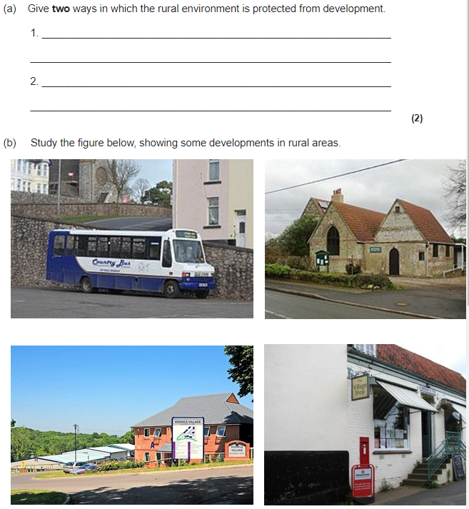

Changing Economic World Page 25&26
Question | A B C
- What is the north-south divide? |  | Cultural and economic differences in the north and south of London | Cultural and economic similarities in the north and south of the UK | Cultural and economic differences in the west and east of the world
- List one social difference between quality of life in the north and south of the UK. |  | People in the south have a longer life expectancy | People in the north have higher wages | People in the south have lower house prices.
- List one economic difference between quality of life in the north and south of the UK. |  | People in the south have a longer life expectancy | People in the south have higher wages | People in the south have lower house prices.
- How did de-industrialisation cause the north south divide? |  | Factories and coal fields opened in the south = employment. | Factories and coal field closed down in the north = unemployment. | Factories and coal fields closed down in the south = unemployment.
- Identify one other cause of the north-south divide. |  | Tertiary jobs were available in the South | Life expectancy was higher in the north. | There were more employment opportunities in the North
- What is the High Speed 2? |  | A fast railway line that connects London and Bristol | A fast railway line that connects London and Paris | A fast railway line that connects London, the midlands and the North.
- How will it reduce the north-south divide? |  | Improve transport connections to companies in the north = improve economy in the north. | Improve transport connections to companies in the north = improve economy in London. | Improve transport connections to companies in the south = improve economy in the south.
- What is a Local Enterprise Partnership (LEP)? |  | Partnerships between local businesses to help create new jobs, improve infrastructure and develop the area. | Partnerships between local businesses to help create leisure facilities and improve infrastructure | Partnerships between national businesses to help create new jobs, improve infrastructure and develop the area.
- Suggest one other way the government has tried to reduce the north-south divide. |  | TNCs opened factories in the north. e.g. Nissan opened a factory to make cars near Newcastle (1984) | TNCs opened factories in the north. e.g. Nissan opened a factory to make cars near Newcastle (1975) | TNCs opened factories in the north. e.g. Nissan opened a factory to make cars near Newcastle (1964)
THE UK’S LINKS WITH THE WIDER WORLD
- State three ways the UK is linked with other countries. |  | Trade, commonwealth, EU | Trade, commonwealth, Shell oil | Commonwealth and Wi-Fi connections
- What is the Commonwealth? |  | Countries that were previously part of the British Empire | Countries that were previously part of NATO | Countries that were previously part of Shell Oil
- State the number of countries in the commonwealth. |  | 53 | 55 | 35
- How often do the heads of state in the commonwealth meet? |  | Every 2 years | Every 4 years | Every year
- What values do countries within the Commonwealth share. |  | Scholarship and human rights | Human Rights & trade | Inclusion and trade
- What is the European Union (EU)? |  | A group of 28 countries within Europe that allow the free movement of people and trade. | A group of 28 countries within East Asia that allow the free movement of people and trade | A group of 20 countries within Europe that allow the free movement of people and trade
- In what year did the UK join the EU? |  | 1973 | 1977 | 1970
- List two countries within the EU. |  | Germany, France | France, Nigeria | Germany, USA
- How does the free movement of people within the EU affect migration to the UK? |  | Fewer people move to the UK. | More people move to the UK for better paid work. | More people move from the UK to mainland Europe.
- The EU makes it easier to trade between countries within the EU (free movement of goods). How did this affect the UK’s trading partners? |  | Most of the UK’s trading partners are within the EU | Most of the UK’s trading partners are from Asia | Most of the UK’s trading partners are from North America.
- How did the EU support farmers in the UK? |  | £10 million to support dairy farmers | £8 million to support dairy farmers | £18 million to support dairy farmers.
- Identify a transport link that connects the UK with other countries. |  | Bristol’s poo bus | The Channel Tunnel | Cross rail
- In 2014 how many people have access to the internet? |  | 3 billion people | 4 billion people | 3.5 billion people
- How many e-mails were sent each day in 2013? |  | 183billion people | 184billion people | 138billion people
- How have improved communications affected the UK’s links with the wider world. |  | 40% of the global population have access to the internet | 90% of the global population have access to the internet | 40% of the UK population have access to the internet

Changing Economic World Page 25&26
Question
- What is the north-south divide?
- List one social difference between quality of life in the north and south of the UK.
- List one economic difference between quality of life in the north and south of the UK.
- How did de-industrialisation cause the north south divide?
- Identify one other cause of the north-south divide.
- What is the High Speed 2?
- How will it reduce the north-south divide?
- What is a Local Enterprise Partnership (LEP)?
- Suggest one other way the government has tried to reduce the north-south divide.
THE UK’S LINKS WITH THE WIDER WORLD
- State three ways the UK is linked with the world.
- What is the Commonwealth?
- State the number of countries in the commonwealth.
- How often do the heads of state in the commonwealth meet?
- What values do countries within the Commonwealth share.
- What is the European Union (EU)?
- In what year did the UK join the EU?
- List two countries within the EU.
- How does the free movement of people within the EU affect migration to the UK?
- The EU makes it easier to trade between countries within the EU (free movement of goods). How did this affect the UK’s trading partners?
- How did the EU support farmers in the UK?
- Identify a transport link that connects the UK with other countries.
- In 2014 how many people have access to the internet?
- How many e-mails were sent each day in 2013?
- How have improved communications affected the UK’s links with the wider world.

THE CHANGING ECONOMIC WORLD PART 5 (page 26)

Study Figure 1, showing a mobile phone sold in the UK.
- Is the mobile phone an import or export to the UK? (1 mark)
- The mobile phone was made by a transnational corporation (TNC). What is a TNC? (1 mark)

The UK is one of the most connected countries in the world. Use evidence to support this statement. (6 marks)

Until recently, the UK was a member of the EU.
- How did this provide social and economic benefits for the UK? (6 marks)
- Suggest one negative impact of being a member in this trade group. (2 mark)

What is the Commonwealth? (2 marks)
Describe how members of the Commonwealth are linked with one another. (4 marks)

Figure 1

