|  |  |  |  |  |
| --- | --- | --- | --- | --- |
| Urbanisation Page 17 | | | | |
| Question | **A B C** | | | |
| 1. In 2015 what percentage of the world live in urban areas? | | 15% | 55% | 45% |
| 1. State the predicted percentage of people that will live in urban areas in 2050. | | 70% | 50% | 10% |
| 1. Define urban growth. | | Decrease of people living in towns and cities. | Increase in people living in towns and cities. | Increase in people living in the countryside. |
| 1. Where is urban growth occurring more rapidly? | | LIC | NEE | HIC |
| 1. Define rural to urban migration | | The movement of people from rural to urban areas. | The movement of people from urban to rural areas. | The amount of people that live in urban areas. |
| 1. As a country develops from a LIC to HIC, it goes through industrialisation. This results in a growth in… | | Agriculture | High tech companies | Manufacturing |
| 1. Rural to urban migration is one cause of urban growth. Identify two push factors. | | Farming is poorly paid  Fewer doctors | Lack of education Better paid jobs | More schools Range of entertainment opportunities |
| 1. Rural to urban migration is one cause of urban growth. Identify two pull factors. | | Lack of education Natural disasters. | More schools Range of entertainment opportunities | Farming is poorly paid More schools |
| 1. State the population needed of a city to be defined as a megacity. | | >5 million | >10 million | >20 million |
| 1. Give the name of a megacity and the country where it is located. | | Mumbai (India) | London (United Kingdom) | Lagos (Nigeria) |
| 1. Natural increase is the other cause of urban growth. What does this mean? | | When a country has a higher death rate than broth rate. | People are moving to the cities increasing the population. | When a country has higher birth rate than death rate. |
| 1. In what stages of the DTM does natural increase occur? | | Stages 1 and 2 | Stages 2 and 3 | Stages 3 and 4 |
| 1. Which of LIC, NEE or HIC are in the stages of DTM where natural increase occurs? | | LICs | HICs | NEEs |
| 1. Give one reason why urban growth is occurring slowly in HICs | | There is a low birth rate and a low death rate. | There is a high birth rate and a high death rate. | There is a low death rate and a high birth rate. |
| 1. Economic development in NEEs, results in more jobs in…. | | Urban areas | Rural areas | Rural and urban areas |
| 1. Counter-urbanisation is occurring in HICs. How does this affect urban populations? | | Urban populations are reduced. | Urban populations are increased. | More people live in the city. |
| 1. Give one reason for counter-urbanisation in HICs. | | Less pollution in the countryside. | People like to live in cities. | People do not like the longer commute. |
| 1. When did the UK go through industrialisation? | | 1900s | 1700s | 1800s |

|  |
| --- |
| Urbanisation Page 17 |
| Question |
| 1. In 2015 what percentage of the world live in urban areas? |
| 1. State the predicted percentage of people that will live in urban areas in 2050. |
| 1. Define urban growth. |
| 1. Where is urban growth occurring more rapidly? |
| 1. Define rural to urban migration |
| 1. As a country develops from a LIC to HIC, it goes through industrialisation. This results in a growth in… |
| 1. Rural to urban migration is one cause of urban growth. Identify two push factors. |
| 1. Rural to urban migration is one cause of urban growth. Identify two pull factors. |
| 1. State the population needed of a city to be defined as a megacity. |
| 1. Give the name of a megacity and the country where it is located. |
| 1. Natural increase is the other cause of urban growth. What does this mean? |
| 1. In what stages of the DTM does natural increase occur? |
| 1. Which of LIC, NEE or HIC are in the stages of DTM where natural increase occurs? |
| 1. Give one reason why urban growth is occurring slowly in HICs |
| 1. Economic development in NEEs, results in more jobs in…. |
| 1. Counter-urbanisation is occurring in HICs. How does this affect urban populations? |
| 1. Give one reason for counter-urbanisation in HICs. |
| 1. When did the UK go through industrialisation? |

**URBAN ISSUES AND CHALLENGES PART 1 (page 17)**

What is meant by the term urbanisation? (1 marks)

What is meant by the term urban growth? (1 mark)

What is meant by the term migration? (1 marks)

What is the difference between voluntary migration and forced migration? (3 marks)

What is meant by the term natural increase? (1 mark)

Study Figure 1, a map showing the percentage of the population living in urban settlements in different parts of the world.

1. Describe two differences in the percentages of population living in urban settlements in South American and Africa. (2 marks)
2. Suggest two reasons for the slow rate of urban growth in many higher income countries. (2 marks)

Study Figure 2, a graph showing changes in the world’s rural and urban population from 1950 to 2050 (predicted). Describe how urban populations have changed. (4 marks)

Study the graph in Figure 3, which shows the population living in urban areas in the world and by continent. 1950-2030. Explain the differences in urban growth between HICs and LICs. (4 marks)

Study Figure 4, a table showing estimated population change in a number of cities.

1. Which city is predicted to have the largest increase in population between 2000 and 2015? (1 mark)
2. Use the figure to compare the estimated population changes of cities in more developed countries and less developed countries. (4 marks)
3. Give two reasons why people in LICs are attracted to urban areas. (2 marks)

Explain how natural increase and migration lead to the growth of the urban population in LICs. (4 marks)

Study Figure 5, which shows information about living in an urban world. Describe the changes in urban population between 1950 and 2020 as shown on the graph. (2 marks)

Study Figure 6, a graph showing information about the percentage of the population living in urban areas.

1. Compare the estimated rate of change in Asia with that in North America. (2 marks)
2. Suggest one reason for the estimated rate of change in North America (2 marks)
3. In which continent is the percentage of population living in urban areas estimated to increase the most between 2000 – 2025? (1 mark)
4. Suggest one reason why the percentage increase in urban population in Asia is high. (1 mark)

Study Figure 7, an article that gives information about why people move to cities. The reasons why people move to cities in LICs are often described as ‘push’ and ‘pull’ factors.

1. Using the figure, explain what is meant by a: (4 marks)

* Push factor:
* Pull factor:

1. Describe the pull factors which help to explain the rapid growth or urban growth in LICs.

Study Figure 8, a table showing ‘the growth of cities’. Use the able to compare the growth of LIC and HIC cities. (4 marks)

**Figure 2**

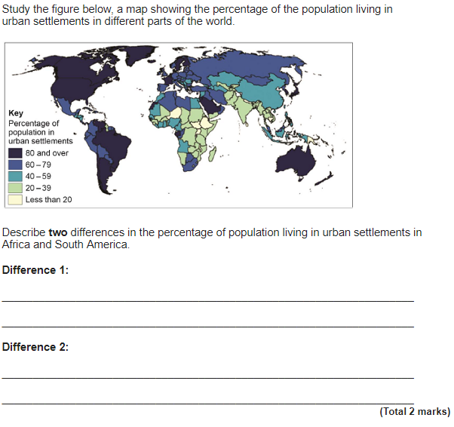

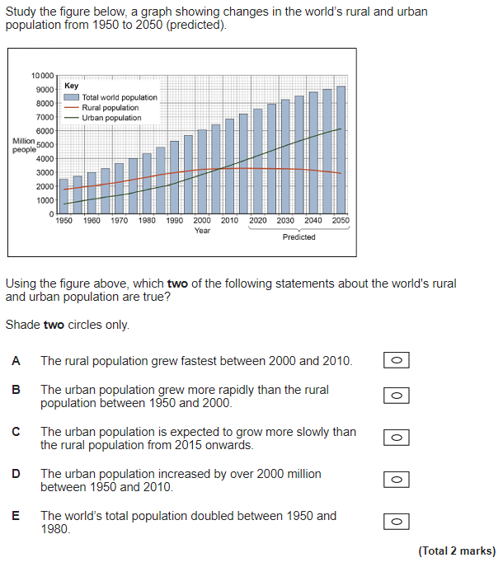

**Figure 1**

**Figure 5**

**Figure 3**

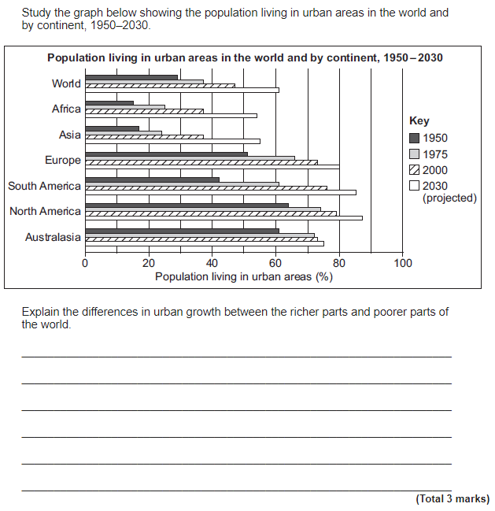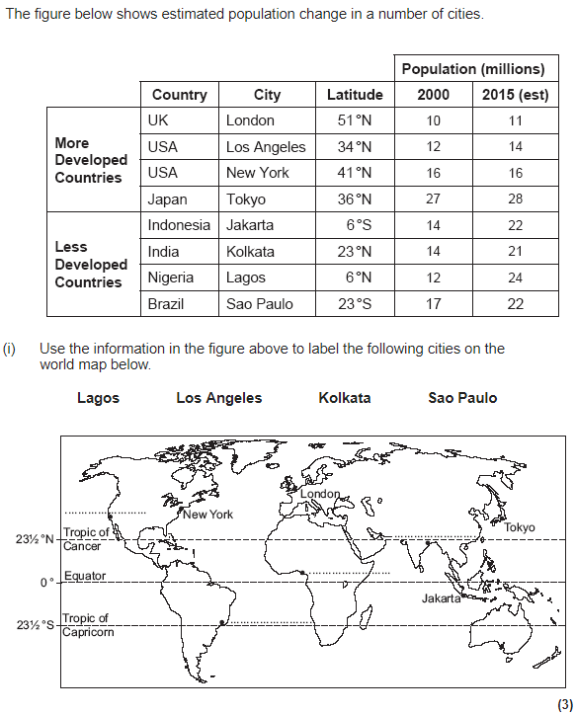

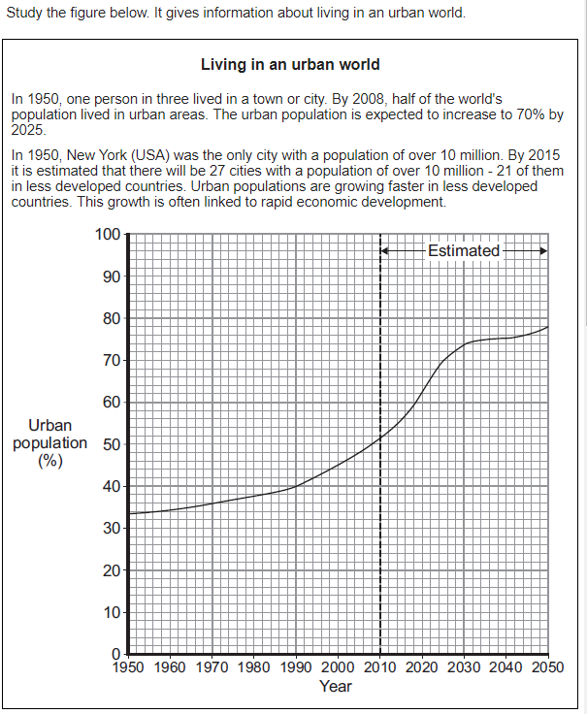

**Figure 4**

**Figure 6**

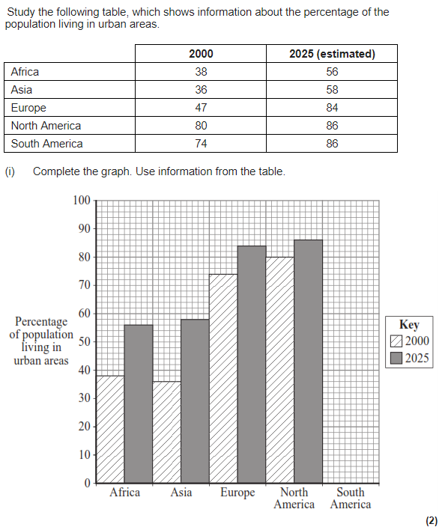

**Figure 7**

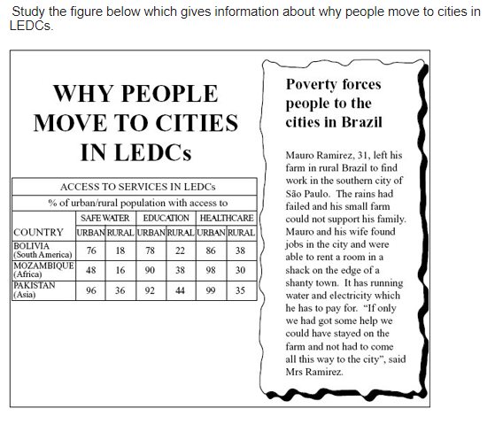

**Figure 8**

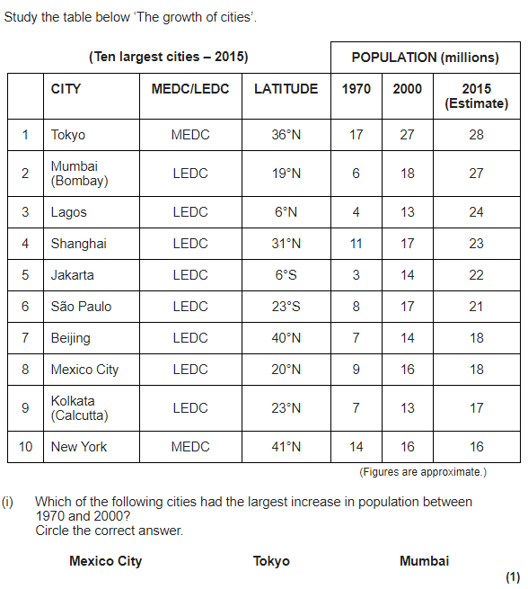

|  |  |  |  |  |
| --- | --- | --- | --- | --- |
| Urbanisation Page 18 | | | | |
| Question | **A B C** | | | |
| 1. Locate Rio de Janeiro | | Guanabara Bay. South East coast of Brazil. | Guanabara Bay. South West coast of Brazil. | Central Brazil. |
| 1. Give the name of the world famous even that happens in Rio every year. | | Rio Carnival | 2016 Olympics | Football World Cup |
| 1. What did Rio de Janeiro host in 2014 and 2016? | | 2014: Olympics 2016: World Cup | 2014: World Cup  2016: Olympics | Rio Carnival  World Cup |
| **SOCIAL & ECONOMIC OPPORTUNITIES IN RIO DE JANEIRO DUE TO URBAN GROWTH** | |  | | |
| 1. List one economic opportunity in Rio | | Rio is growing = there are jobs in construction. | There is a better access to education. | There is unemployment. |
| 1. >….% of all jobs in Brazil are in found in Rio | | 10% | 6% | 12% |
| 1. What does the government provide families to ensure access to an education? | | Loans for poor families to go to school. | Adults are not allowed to go to school. | Grants for poor families to go to school. |
| 1. Suggest how better access to education is a social opportunity. | | Education gives people skills for life and jobs. | Volunteers help in schools. | Education gives people jobs. |
| 1. What has been installed to ensure there is enough electricity in Rio. | | 10km of new electricity lines. | 120km of new electricity lines. | 60km of new electricity lines. |
| 1. How many sewage works have been built in Rio? | | 5km | 15km | 50km |
| 1. How many kilometres of water pipes have been recently laid in Rio? | | 20km | 3km | 300km |
| 1. What is the life expectancy in Rio and what is the average life expectancy in Brazil? | | Rio: 60 years  Brazil: 80 years | Rio: 80 years  Brazil: 63 years | Rio: 63 years  Brazil: 80 years |
| 1. Suggest one form of international transport people in Rio can use. | | Two major airports | Teleportation | Motorways |
| 1. Suggest entertainment options that are available in Rio. | | Statue of Christ the Redeemer | 2014: World Cup | Amazon rainforest |
| **SOCIAL, ECONOMIC & ENVIRONMENTAL CHALLENGES CAUSED DUE TO URBAN GROWTH** | |  | | |
| 1. What percentage of people in Rio have access to a family health clinic? | | 95% | 55% | 45% |
| 1. Identify a problem within education in Rio. | | Not enough homework | Volunteers in schools | Not enough schools |
| 1. What percentage of people in Rio still do not have access to running water. | | 12% | 24% | 7% |
| 1. Due to illegal tapping of electric lines, what negative social impact has occurred? | | Electricity blackouts | People have better access to electricity. | More electricity is produced |
| 1. Identify an economic challenge caused by urban growth in Rio. | | No taxes are paid as people work in the informal sector. | More businesses are attracted to the area. | No taxes are paid as people work in the quaternary sector. |
| 1. How many deaths are caused each year by air pollution? | | 5000 deaths | 1000 deaths | 500deaths |
| 1. There is still a lot of sewage running into rivers each day. How much? | | 2 tonnes | 12 tonnes | 200 tonnes |
| 1. What is a squatter settlement? | | Settlements that are small | Illegal settlements on the outskirts of cities. | Settlements built by the government. |
| 1. Squatter settlements in Rio are built on steep slopes. What do they suffer from as a result? Provide an example. | | Landslides (e.g. in 2010 a landslide killed 224 people) | People cannot access the houses at the top because the slopes are very steep. | Landslides (e.g in 2010 a landslide killed 100 people) |
| 1. What percentage of people are unemployed in squatter settlements? | | 10% | 80% | 20% |
| 1. What is the rate of murder in squatter settlements? | | 80 per 1000 people. | 10 per 1000 people. | 20 people per 1000 people. |
| 1. What percentage of people in squatter settlements do not have access to electricity or sewage systems? | | Electricity: 30%  Sewage: 50% | Electricity: 50%  Sewage: 30% | Electricity: 50%  Sewage: 50% |
| 1. What is a cause of the high infant mortality rates? | | Spread of diseases. | Babies are dying. | There is access to healthcare. |
| **URBAN PLANNING IN RIO: FAVELA BAIRRO PROJECT** | |  | | |
| 1. Define urban planning. | | More people living in favelas. | Improving the quality of life in favelas. | Improving the quality of life in Brazil. |
| 1. What is a site and service scheme? | | Government provides infrastructure and locals complete the construction. | Government provides materials infrastructure and labour. | Locals build their own houses from recycled materials. |
| 1. What favela did the Favela Bairro Project help? | | Complexo de Alemao | Rio de Janerio | Dharvi |
| 1. They improved access to water and sanitation. How did this improve quality of life? | | Less people die of waterborne diseases. | Better access to healthcare | Education was improved. |
| 1. They built a cable car that connected the favela to Ipanema (central Rio). How did this improve quality of life? | | Favela residents have to pay for a return ticket. | People travel by cable car | People have access to jobs in the city centre. |
| 1. They installed a Pacifying Police Unit. How did this improve quality of life? | | Less crime | People have access to jobs in the city centre. | Less people die of waterborne diseases |
| 1. They provided 100% mortgages. How did this improve quality of life? | | People travel by cable car | Locals can buy homes | Grants to send children to school. |
| 1. List one other improvement they made. | | Houses were built on steep slopes | Hillsides were strengthened to reduce landslides | People are employed in the informal sector. |
| 1. Identify one way the changes were unsuccessful. | | People could buy their own homes. | All favelas could be helped. | Locals did not have the skills to fix the new infrastructure. |
| 1. Identify a second way the changes were unsuccessful. | | A budget of US$1 could not help all favelas | Locals could fix the new infrastructure. | There was less crime |

|  |
| --- |
| Urbanisation Page 18 |
| Question |
| 1. Locate Rio de Janeiro |
| 1. Give the name of the world famous even that happens in Rio every year. |
| 1. What did Rio de Janeiro host in 2014 and 2016? |
| **SOCIAL & ECONOMIC OPPORTUNITIES IN RIO DE JANEIRO DUE TO URBAN GROWTH** |
| 1. List one economic opportunity in Rio |
| 1. >….% of all jobs in Brazil are in found in Rio |
| 1. What does the government provide families to ensure access to an education. |
| 1. Suggest how better access to education is a social opportunity. |
| 1. What has been installed to ensure there is enough electricity in Rio. |
| 1. How many sewage works have been built in Rio? |
| 1. How many kilometres of water pipes have been recently laid in Rio? |
| 1. What is the life expectancy in Rio and what is the average life expectancy in Brazil? |
| 1. Suggest one form of international transport people in Rio can use. |
| 1. Suggest entertainment options that are available in Rio. |
| **SOCIAL, ECONOMIC & ENVIRONMENTAL CHALLENGES CAUSED DUE TO URBAN GROWTH** |
| 1. What percentage of people in Rio have access to a family health clinic? |
| 1. Identify a problem in the education sector in Rio. |
| 1. What percentage of people in Rio still do not have access to running water. |
| 1. Due to illegal tapping of electric lines, what has occurred? |
| 1. Identify an economic challenge caused by urban growth in Rio. |
| 1. How many deaths are caused each year by air pollution? |
| 1. There is still a lot of sewage running into rivers each day. How much? |
| 1. What is a squatter settlement? |
| 1. Squatter settlements in Rio are built on steep slopes. What do they suffer from as a result? Provide an example. |
| 1. What percentage of people are unemployed in squatter settlements? |
| 1. What is the rate of murder in squatter settlements? |
| 1. What percentage of people in squatter settlements do not have access to electricity or sewage systems? |
| 1. What is a cause of the high infant mortality rates? |
| **URBAN PLANNING IN RIO: FAVELA BAIRRO PROJECT** |
| 1. Define urban planning. |
| 1. What is a site and service scheme? |
| 1. What favela did the Favela Bairro Project help? |
| 1. They improved access to water and sanitation. How did this improve quality of life? |
| 1. They built a cable car that connected the favela to Ipanema (central Rio). How did this improve quality of life? |
| 1. They installed a Pacifying Police Unit. How did this improve quality of life? |
| 1. They provided 100% mortgages. How did this improve quality of life? |
| 1. List one other improvement they made. |
| 1. Identify one way the changes were unsuccessful. |
| 1. Identify a second way the changes were unsuccessful. |

**URBAN ISSUES AND CHALLENGES PART 2 (page 18)**

Explain how urban areas in less developed countries provide opportunities for economic development. (6 marks)

Describe how urban areas in LICs or NEEs provide social and economic opportunities for people? (6 marks)

Give two problems caused by rapid urbanisation for cities in LICs and NEEs. (2 marks)

Study Figure 1, a photograph showing pollution in rapidly urbanising countries. Using the photograph and your own knowledge explain how rapid urbanisation and industrialisation in LICs and NEEs lead to pollution in urban areas. (8 marks)

Study Figure 2, a report of an interview with a resident of a squatter settlement in Manila, a city in the Philippines.

1. In which sector of the economy does Marina work: *formal, primary or information?* (1 mark)
2. Suggest how Marina’s life has been improved by living in a squatter settlement (2 marks)
3. Describe how squatter settlements provide challenges for people living in them. (4 marks)

Study Figure 3, information about Lagos, Nigeria.

1. Use the pictures to give two reasons why water pollution is a problem in Lagos. (2 marks)
2. Suggest the effect(s) of water pollution on a poor world city such as Lagos (2 marks)
3. Outline why reducing water pollution would be difficult for a poor world city, such as Lagos. (2 marks)

Study Figure 4, a graph showing changing car ownership in India and in the USA.

1. Using Figure 4, describe how car ownership has changed in LICs and HICs. (4 marks)
2. Describe the environmental problems caused by urban growth. Use the figure and your own knowledge. (4 marks)

Study Figure 5, which gives details of a squatter settlement in the poor country of Indonesia.

1. Give two locations within a poor world city where squatter settlements are often found. (2 marks)
2. Use a named case study to describe the main features of a squatter settlement redevelopment. (6 marks)

Study Figure 6, a sketch map of Bangkok, the capital of Thailand in South East Asia.

1. Describe the distribution of squatter settlements in this region. (3 marks)
2. Suggest reasons for the distribution of the shanty towns in Bangkok. (4 marks)

Study Figure 7, which shows why the city of Kolkata (Calcutta) has frown as a result of migration and other factors.

1. Using the figure above give two physical and two human factors that caused a growth in Kolkata’s population. (4 marks)
2. Describe the effects of rapid growth on LIC cities, such as Kolkata. (4 marks)
3. Suggested strategies to cope with the rapid growth of cities in LICs and NEEs include: transport policies, improving shanty towns and use of brownfield sites. Explain how two of these may help to cope with the rapid growth of cities. (4 marks)

Explain how urban growth in LICs and NEEs provide social, economic and environmental challenges. Use a case study and your own knowledge. (9 marks)

Use a case study to explain how squatter settlements can be improved. (8 marks)

Assess the impact or an urban planning scheme you have studied. (9 marks)

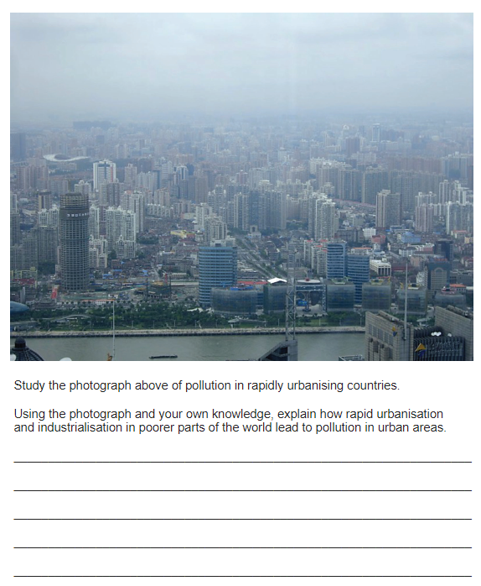

**Figure 1**

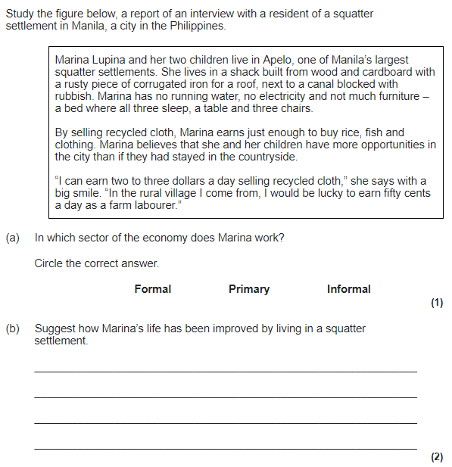

**Figure 2**

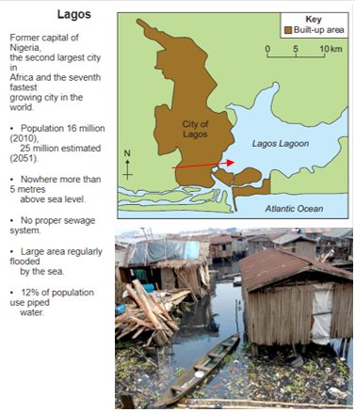

**Figure 3**

**Figure 4**

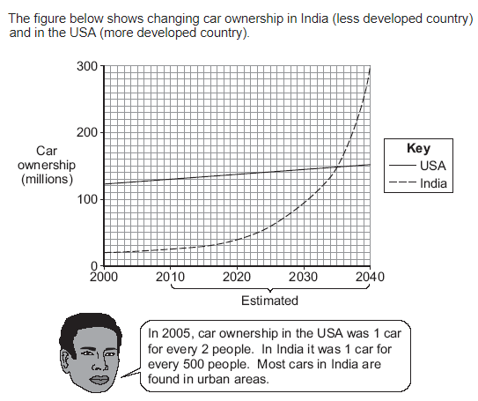

**Figure 5**

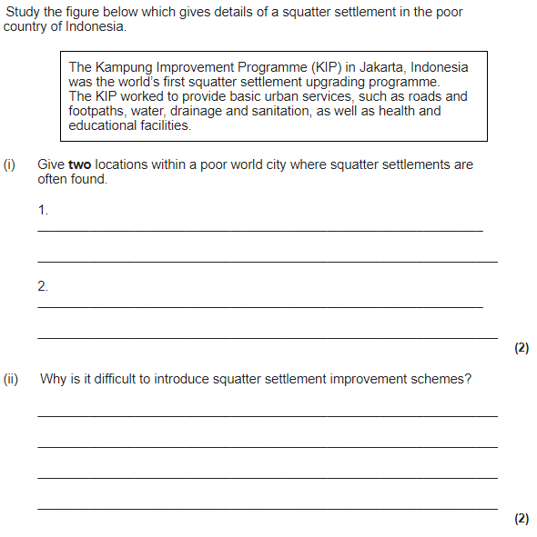

**Figure 6**

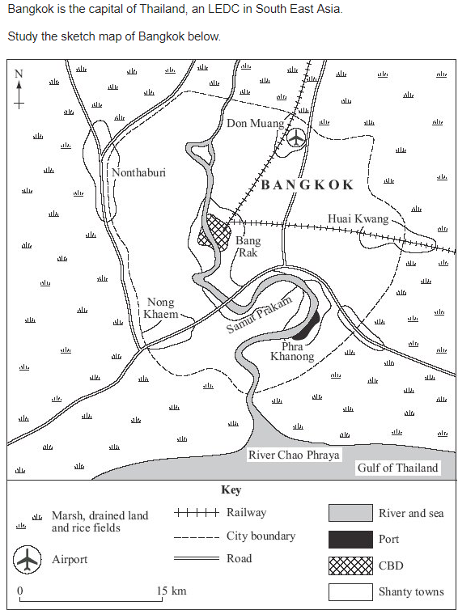

**Figure 7**

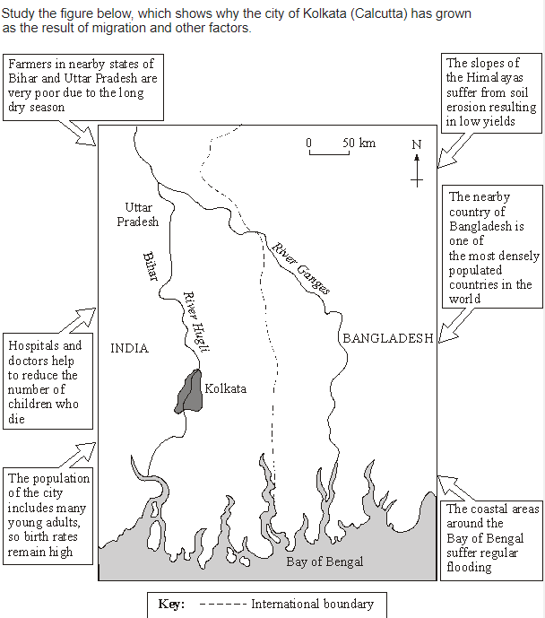

|  |  |  |  |  |
| --- | --- | --- | --- | --- |
| Urbanisation Page 19 | | | | |
| Question | **A B C** | | | |
| 1. Identify the percentage of people that live in urban areas in the UK. | | 82% | 72% | 22% |
| 1. Give two reasons why more people live in south east England. | | Flat land and less rainfall. | Close to shops | Sunny all the time. |
| 1. Where is Bristol located? | | South West of England. | South East of England. | South West of Scotland. |
| 1. Identify the expected population of Bristol in 2029. | | 500,000 | 50,000 | 500 |
| 1. International migration has accounted for …..% of population growth. | | 55% | 5% | 50% |
| 1. Identify one advantage of a multicultural population. | | Enrich the culture of the city (food, music) | People can watch TV with other people. | Enrich the culture of London (food, music) |
| 1. Identify one disadvantage of a multicultural population. | | People find it hard to meet their friends. | There is a pressure on the amount of food in the shops in Bristol. | Pressure on housing, healthcare and education |
| 1. Suggest two reasons why people move to Bristol. | | Two universities and economic opportunities. | It is a nice place to live, people are friendly. | High unemployment and good entertainment. |
| **SOCIAL, ECONOMIC & ENVIRONMENTAL OPPORTUNITIES CAUSED BY URBAN GROWTH** | |  | | |
| 1. Identify one social opportunity in Bristol. | | Cabot Circus shopping centre. | People have jobs | Electric buses for transport. |
| 1. What is a social impact of Bristol’s improved transport system? | | Faster journeys due to the metrobus and integrated transport system | It is cheaper. | It causes less air pollution. |
| 1. What new recreation opportunities are there in Bristol? | | Bristol Rovers are building a new football stadium. | More people can go to the theatre, such as the Old Vic | There is a faster connection for people to shop in London. |
| 1. Identify one economic opportunity in Bristol. | | Increased number of quaternary sector jobs on the outskirts of Bristol. | Increase in the number of manufacturing jobs in Bristol. | Increased jobs in the construction industry. |
| 1. What sector are most jobs in Bristol within? | | Tertiary sector | Primary sector | Secondary sector |
| 1. Redevelopment of brownfield sites has attracted businesses. How has that brought economic opportunity for the local area? | | People have jobs in the primary sector, this gives them an income. | People do not have jobs and money is not spent in the local area. | People have jobs, and more disposable income. |
| 1. What did the government spend £100 million on to attract high tech industries? | | Superfast broadband creating a super connected city. | The rapid transit network. | Highly skilled university graduates. |
| 1. Suggest two high tech companies that operate in Bristol. | | Windows, Shell | Hewlett Packard, Toshiba | Rolls Royce, KFC |
| 1. What is Bristol’s Integrated Transport System? What does it link? | | The ITS improves rail links to London. | The ITS links people with car shares | The ITS links Temple Meads railway station and the park and ride network. |
| 1. How does the ITS help keep Bristol green? | | The ITS has helped the city to grow. | The ITS reduces traffic congestion and pollution in the city. | The ITS makes more traffic and pollution in the city. |
| 1. Define urban greening. | | Giving out free plants. | Increasing the amount of green space in a city. | Painting the walls of the city green. |
| 1. Suggest one way Bristol has increased the amount of green space in the city. | | 30% of the city is covered in trees. | 90% of the city is covered in trees. | 3% of the city is covered in trees. |
| 1. What percentage of the population live within 350m of a park? | | 30% of people live within 350m of a park. | 12% of people live within 350m of a park. | 90% of people live within 350m of a park. |
| 1. In what year was Bristol awarded the status of: European Green Capital? | | 2015 | 2005 | 2010 |
| 1. How many electric car charging points were installed in 2015? | | 1000 electric charging points | 100 electric charging points | 10 electric charging points |
| 1. In 2015 every primary pupil in Bristol… | | Handed out flyers | Planted a tree | Took the bus |
| 1. Bristol also pledges to increase the use of… | | Recycling bin | Public transport | Renewable energies |

|  |
| --- |
| Urbanisation Page 19 |
| Question |
| 1. Identify the percentage of people that live in urban areas in the UK. |
| 1. Give two reasons why more people live in south east UK. |
| 1. Where is Bristol located? |
| 1. Identify the expected population of Bristol in 2029. |
| 1. International migration has accounted for …..% of population growth. |
| 1. Identify one advantage of a multicultural population. |
| 1. Identify one disadvantage of a multicultural population. |
| 1. Suggest two reasons why people move to Bristol. |
| **SOCIAL, ECONOMIC & ENVIRONMENTAL OPPORTUNITIES CAUSED BY URBAN GROWTH** |
| 1. Identify one social opportunity in Bristol. |
| 1. What is a social impact of Bristol’s improved transport system? |
| 1. What new recreation opportunities are there in Bristol? |
| 1. Identify one economic opportunity in Bristol. |
| 1. What sector are most jobs in Bristol within? |
| 1. Redevelopment of brownfield sites has attracted businesses. How has that brought economic opportunity for the local area? |
| 1. What did the government spend £100 million on to attract high tech industries? |
| 1. Suggest two high tech companies that operate in Bristol. |
| 1. What is Bristol’s Integrated Transport System? What does it link? |
| 1. How does the ITS help keep Bristol green? |
| 1. Define urban greening. |
| 1. Suggest one way Bristol has increased the amount of green space in the city. |
| 1. What percentage of the population live within 350m of a park? |
| 1. In what year was Bristol awarded the status of: European Green Capital? |
| 1. How many electric car charging points were installed in 2015? |
| 1. In 2015 every primary pupil in Bristol… |
| 1. Bristol also pledges to increase the use of… |

**URBAN ISSUES AND CHALLENGES PART 3 (page 19)**

Within the UK, 82% of the population live in urban areas. Suggest two reasons why. (4 marks)

Using an example you have studied, suggest how international migration has affected the town or city. (4 marks)

Using an example of an urban area in the UK, explain why people migrated to the town or city. (4 marks)

Study Figure 1, a photograph showing a brownfield site in New Islington, Manchester.

1. What is a brownfield site? (1 mark)
2. Using the figure and your own knowledge, describe the benefits of using brownfield sites. (4 marks)
3. Give on disadvantage of building on brownfield sites. (1 mark)

Using a case study, describe how urban growth in UK cities has created social, economic and environmental opportunities. (9 marks)

Describe how the growth of urban areas has created social opportunities. (4 marks)

Use a named example to describe how the growth of urban areas in the UK has provided economic development. (4 marks)

What is meant by the term urban greening. (2 marks)

Using an example describe how urban greening provides social and environmental advantages. (6 marks)

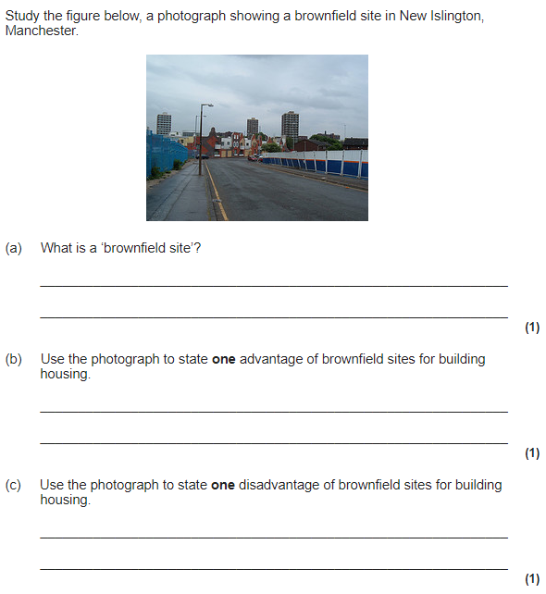

**Figure 1**

|  |  |  |  |  |
| --- | --- | --- | --- | --- |
| Urbanisation Page 20 | | | | |
| Question | **A B C** | | | |
| **CHALLENGES CAUSED BY URBAN GROWTH** | |  | | |
| **Challenge one: rise in derelict areas** | |
| 1. Suggest two reasons why many inner city areas in Bristol became derelict in the 20th century. | | Growth of tertiary and quaternary industries. | Decrease in manufacture abroad. | The inner city port closed down. |
| 1. Identify an area that became derelict. | | The Temple Quarter | Cabot circus | Bradley Stokes |
| 1. Identify one way the government have tried to improve derelict areas. | | Lottery grants have helped improve the area of Stokes croft. | One person paid to improve the area of Stokes Croft. | The locals decided to raise money to improve the area of Stokes Croft. |
| **Challenge two: urban sprawl** | |  | | |
| 1. Define urban sprawl | | Unplanned growth of rural areas into the surrounding urban areas. | Planned growth of urban areas into the surrounding rural areas. | Unplanned growth if of urban areas into the surrounding rural area. |
| 1. Define rural-urban fringe | | The area on the edge of the city, where it meets the countryside. | The area on the edge of the city where people can’t travel on public transport. | The area on the edge of the city where trees start to grow. |
| 1. Define greenfield site | | Land that has never previously been planted on. | Land that has never previously been built on. | Land that has previously been built up on. |
| 1. Define brownfield site | | Land that has never previously been built on. | Land that has only been built on once before. | Land that has previously been built on. |
| 1. What are two causes of urban sprawl in Bristol? | | Increase in population. | Houses were bombed during WW2 = not enough. | Increase in shopping centres on the outskirts of the city. |
| 1. Identify two greenfield sites that were built on due to urban sprawl. | | Harry Stokes | Bradley Stokes | The Temple Quater |
| 1. Suggest one advantage of developing on greenfield sites. | | It is cheaper | It is better for the environment. | People can look at what was already there for inspiration. |
| 1. Suggest one environmental disadvantage of developing on greenfield sites. | | It is cheaper | Loss of habitats | There is a decreased risk of flooding |
| 1. What has the government done to reduce the urban sprawl? | | Increased the number of developments on brownfield sites. | Decreased the number of developments on brownfield sites. | Insisted people live in different cities. |
| 1. What percentage of new housing developments were built on brownfield sites between 2006-2013? | | 94% | 6% | 60% |
| 1. Provide an example of a brownfield site that has been redeveloped and identify one economic benefit it has. | | The Temple Quarter. Created enterprise zones. | The Temple Quarter. Built Bristol Arena. | The Temple Quarter. Improved public transport. . |
| **Challenge three: waste disposal** | |  | | |
| 1. How much waste does Bristol produce each year? | | 500,000 tonnes | 50,000 tonnes | 50 tonnes |
| 1. Suggest one way the government have reduced issues caused by waste disposal. | | Reduced the amount of waste recycled. | Reduced the waste sent to landfill. | Reduced the amount of waste in the city centre |
| **Challenge four: air pollution** | |  | | |
| 1. How many deaths does air pollution in Bristol cause annually? | | 200 deaths per year | 20 deaths per year | 220 deaths per year |
| 1. Provide one reason for the high level of air pollution in Bristol. | | The prevailing winds blow pollution from the industrial area. | The prevailing winds blow clean air from the Bristol channel. | The prevailing winds blow pollution from the South Coast |
| 1. Suggest one change to transportation that will reduce air pollution. | | Improved public transport to encourage people to not use their cars. | Decreased the number of cycle routes. | Increased the number of lanes on the roads. |
| 1. Suggest a second way Bristol is reducing air pollution. | | Reduce the amount of waste that is sent to landfill sites. | Lottery grants have been given to derelict areas to improve the area. | Increased the number of electric car charging points in Bristol. |
| **Challenge five: social inequality** | |  | | |
| 1. Define social inequality | | Some areas have more opportunities than others. | Soma areas have less opportunities than others. | Different societies have different opportunities. |
| 1. What is a cause of social inequality? | | Not enough money spent by the local people | Lack of investment from the government. | Different societies spending different amounts of money. |
| 1. What is the difference in life expectancy in Filwood and Stoke Bishop? | | 78years in Filwood 83 years in Stoke Bishop | 83 years in Filwood 75 years in Stoke Bishop | 78 years in Filwood 83 years in Stoke Bishop |
| 1. How many people live in poverty in Stoke Bishop? | | Fewer than 4% | Fewer than 3% | Fewer than 8% |
| 1. What percentage of people live in low income homes in Filwood? | | One third | Two thirds | Three people |
| 1. How many more crimes occur in Filwood per year? | | 1270 more crimes per year than Filwood | 1300 more crimes per year than Filwood | 1720 more crimes per year than Filwood |
| 1. What percentage of students get good GCSE results in Filwood? | | 63% get good GCSEs | 36% get good GCSEs | 38% get good GCSEs |
| 1. What percentage of students get good GCSE results in Stoke Bishop? | | 94% get good GCSEs | 99% get good GCSEs | 96% get good GCSEs |
| **EXAMPLE OF URBAN REGENERATION: THE TEMPLE QUARTER** | |  | | |
| 1. Where is the Temple Quarter located? | | South West Bristol | Central Bristol | South East Bristol |
| 1. How was it used in the 18th century? | | Industrial area | Retail area | High tech industries |
| 1. Identify one reason it went into decline in the 19th and 20th centuries. | | Growth of tertiary services. | People now work in the primary sector. | There were lots of railways. |
| 1. Define urban regeneration project | | The improvement of an area socially, economically and environmentally. | Improvement in the economy of an area so that people have more jobs. | Improvement of an area environmentally- there are more green spaces. |
| 1. How did they improve transportation lines? | | London to Bristol railway line was electrified. | There are more cycle routes. | London to Bristol airport links were improved. |
| 1. Which two ways did the Bristol Arena attract people to the area? | | It can host concerts for up to 4000 people. | Decreased crime rates. | It can hold sporting events for 12,000 spectators. |
| 1. They created enterprise zones (business zones). How did these attract businesses to move to the area? | | The area has Michelin star restaurants. | There was low rent. | The area looks very nice |
| 1. They created the Engine Shed. What type of businesses did this attract? | | High tech tertiary industries. | High tech secondary industries. | High tech quaternary industries. |
| 1. What did they build to ensure the Temple Quarter redevelopment was environmentally friendly? | | Rapid Transit Network means people do not drive. | People walk to work in the city centre. | Rapid Transit Network means people drive more and pollute. |

|  |
| --- |
| Urbanisation Page 20 |
| Question |
| **CHALLENGES CAUSED BY URBAN GROWTH** |
| **Challenge one: rise in derelict areas** |
| 1. Suggest two reasons why many inner city areas in Bristol became derelict in the 20th century. |
| 1. Identify an area that became derelict. |
| 1. Identify one way the government have tried to improve derelict areas. |
| **Challenge two: urban sprawl** |
| 1. Define urban sprawl |
| 1. Define rural-urban fringe |
| 1. Define greenfield site |
| 1. Define brownfield site |
| 1. Why did urban sprawl occur in Bristol? |
| 1. Identify two greenfield sites that were built on due to urban sprawl. |
| 1. Suggest one advantage of developing on greenfield sites. |
| 1. Suggest one environmental disadvantage of developing on greenfield sites. |
| 1. What has the government done to reduce the urban sprawl? |
| 1. What percentage of new housing developments were built on Greenfield sites between 2006-2013? |
| 1. Provide an example of a brownfield site that has been redeveloped and identify one change they have made. |
| **Challenge three: waste disposal** |
| 1. How much waste does Bristol produce each year? |
| 1. Suggest one way the government have reduced issues caused by waste disposal. |
| **Challenge four: air pollution** |
| 1. How many deaths does air pollution in Bristol cause annually? |
| 1. Provide one reason for the high level of air pollution in Bristol. |
| 1. Suggest one change to transportation that will reduce air pollution. |
| 1. Suggest a second way Bristol is reducing air pollution. |
| **Challenge five: social inequality** |
| 1. Define social inequality |
| 1. What is a cause of social inequality? |
| 1. What is the difference in life expectancy in Filwood and Stoke Bishop? |
| 1. How many people live in poverty in Stoke Bishop? |
| 1. What percentage of people live in low income homes in Filwood? |
| 1. How many more crimes occur in Filwood per year? |
| 1. What percentage of students get good GCSE results in Filwood? |
| 1. What percentage of students get good GCSE results in Stoke Bishop? |
| **EXAMPLE OF URBAN REGENERATION: THE TEMPLE QUARTER** |
| 1. Where is the Temple Quarter located? |
| 1. How was it used in the 18th century? |
| 1. Identify one reason it went into decline in the 19th and 20th centuries. |
| 1. Define urban regeneration project |
| 1. How did they improve transportation lines? |
| 1. How did the Bristol Arena attract people to the area? |
| 1. They created enterprise zones (business zones). How did these attract businesses to move to the area? |
| 1. They created the Engine Shed. What type of businesses did this attract? |
| 1. What did they build to ensure the Temple Quarter redevelopment was environmentally friendly? |

**URBAN ISSUES AND CHALLENGES PART 4 (page 20)**

Study Figure 1, an OS map of Dundee, a city in Scotland.

1. What is the rural-urban fringe? (2 marks)
2. Which grid reference shows part of the rural-urban fringe: *3630, 3833, 3930 or 3934?*
3. Discuss the effects of urban sprawl on people and then environment. Use the figure and a case study of a major city in the UK. (6 marks)

The Central Business Districts and Inner Cities in many urban areas in HICs have experienced decline.

1. State one feature that suggests these areas are experiencing decline. (1 mark)
2. Suggest why many inner cities of UK cities have gone into decline. (4 marks)
3. Outline how these areas can be improved. (3 marks)

Providing suitable housing (of the right quality and quantity) is a major issue in many urban areas. Using a named example, explain how the need to provide suitable housing is being met in the inner city and suburbs. (6 marks)

Suggest two ways new housing developments on the edge of a city are likely to be different form brownfield housing developments towards the centre of a city. (2 marks)

A survey measured the quality of life in three different areas within a city in a more developed country. Figure 2 contains the results.

1. Suggest one type of information, other than that used in the table that could be used to measure the quality of life in urban areas. (1 mark)
2. Explain why your chosen type of information would be useful. (2 marks)
3. Describe and explain how a redevelopment project could improve the quality of life in Area A. (6 marks)

Study the table in Figure 3, which shows part of a survey carried out in 2005 in one of the poorest parts of London, a city in a more developed country. Explain how the data in the table suggest that the survey area is one of the more disadvantaged areas of London. (4 marks)

Describe the problems caused by urban growth in HIC cities. (9 marks)

Using a named example, describe what has been done to improve an urban area of a city in the UK. (9 marks)

Describe how urban growth has resulted in increased pollution in HIC towns and cities. (4 marks)

*Social inequality is when some areas have more opportunities than others. It has been caused by rapid urban growth and a lack of investment by the government*. Use evidence and an example to support this statement.

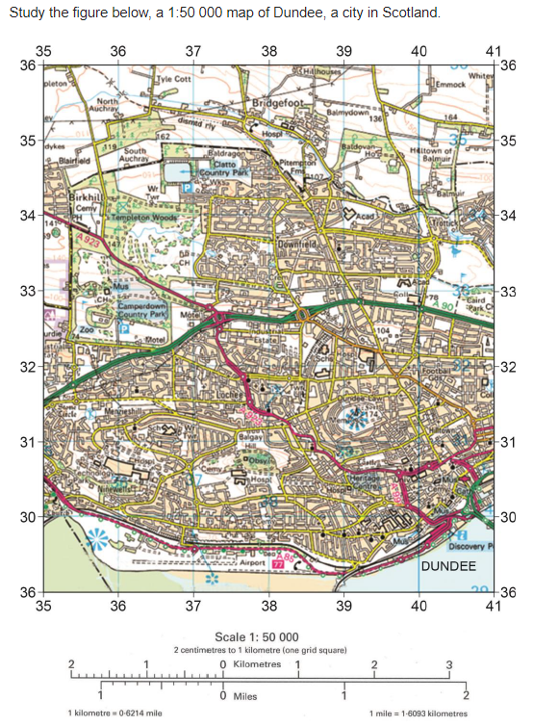

**Figure 1**

**Figure 2**

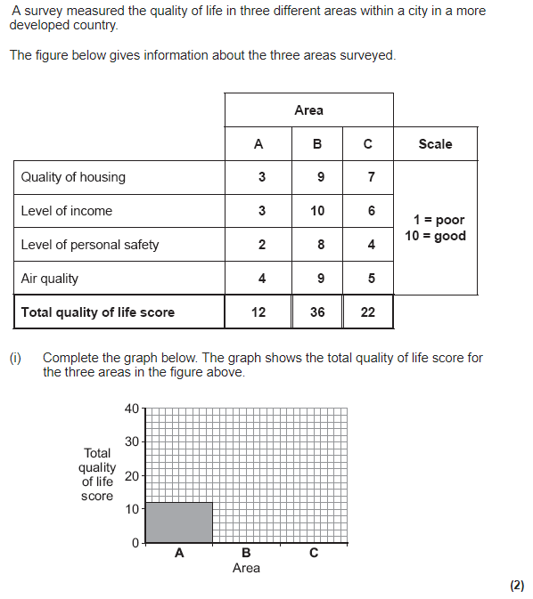

**Figure 3**

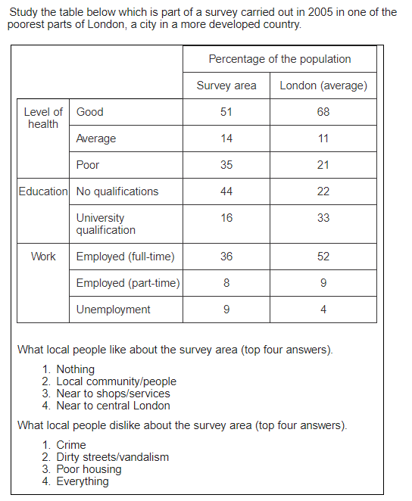

|  |  |  |  |
| --- | --- | --- | --- |
| Urbanisation Page 21 | | | |
| Question | **A B C** | | |
| 1. Define sustainability | Meeting the needs of today without harming the environment for the future. | Meeting the futures needs without harming the environment of today. | Needing the future to support the needs of today. |
| 1. Where is Freiburg located? | South-west Germany | North-East Germany | North- West Germany |
| 1. In what year did it set a goal to become a sustainable city? | 1977 | 1970 | 1990 |
| **GOAL ONE: prevent the overuse of water** |  | | |
| 1. State one way the people of Freibug prevent the overuse of water in their homes | Toilets are installed that use less water when they flush. | They don’t wash their hands as often. | Showers are installed that increase the amount of water used. |
| 1. Identify one way the city collects rain water to reuse. | Water harvesting tanks on roof gardens. | In buckets outside people’s houses. | They absorb the rainwater into the walls of their building. |
| 1. How is the River Dreisam used to provide water to Freiburg? | People can swim in the river. | They store excess water upstream, which is pumped into the city to use in homes/business | People drink the water from the river. |
| 1. How does the use of water meters prevent overuse of water? | People are able to see how much water they are using. | People are able to spend more money on water. | People have showers instead of baths. |
| **GOAL TWO: prevent the overuse of energy and increase the production of renewable energies** |  | | |
| 1. By what year does Freiburg plan to be 100% powered by renewable energy? | 2030 | 2005 | 2050 |
| 1. How many solar panel installations are used in Freiburg? | 400 | 40 | 440 |
| 1. Why is solar power a good strategy in Freiburg? | It is one of the sunniest cities in Germany | It is very hot in Freiburg | It is the second sunniest city in Germany |
| 1. How many kilowatts of energy do the solar panels produce per year? | 15million kilowatts | 10million kilowatts | 1million kilowatts |
| 1. How many people does the solar energy employ in Freiburg? | 100 people | 10 people | 1000 people |
| 1. How have the government encouraged households prevent overusing energy? | The government say solar power is the best option for everyone in Freiburg | Monetary incentives are paid by the government. | Consumers can sell excess energy back to the government if they produce more than they need. |
| **GOAL THREE: increase the amount of green spaces which provide clean air, habitats & prevent flooding** |  | | |
| 1. State how many trees have been planted in the city? | 44,000 trees | 4000 trees | 40 trees |
| 1. What % of deforested trees are re-grown? | 57% | 75% | 25% |
| 1. What percentage of the city is forested? | 40% | 4% | 44% |
| 1. State the amount of open space in the Riselfield District. | 240 hectares | 440 hectares | 244hectares |
| **TRAFFIC MANAGEMENT STRATEGIES** |  | | |
| 1. Identify three problems that traffic congestion can cause. | Higher fuel consumption,  Increased journey time,  Air pollution | Lower fuel consumption,  Increased journey time,  Loss of habitats | Higher fuel consumption,  Decreased journey time,  Air pollution |
| 1. What are cycle routes? | Cycle pathways alongside existing main roads, some exclude cars. | Cycle pathways alongside existing railways, some exclude cars. | Cycle pathways in the middle of main roads. |
| 1. How has Bristol encouraged people to cycle? | 30mph speed limits | 20mph speed limits | 10mph speed limits |
| 1. What is the metrobus? | Improved cycle routes | The electrification of the train line to London. | A new express bus service in Bristol. |
| 1. How does the metrobus in Bristol encourage people to use public transport? | Faster that the trains. | Faster and more reliable than current buses. | Slower than other buses. |
| 1. What is park and ride? | Free car parks that visitors park in. They then take a free bus to the city centre. | People pay to park outside the city centre and then get a free bus to the city. | People park their cars then get a free train into the city centre. |
| 1. What is a social benefit of park and ride? | People can spend more time with each other | There is less time wasted in traffic. | There is less air pollution. |
| 1. What is an environmental benefit of park and ride? | There is less air pollution. | People can spend more time with each other | There is less time wasted in traffic. |
| 1. How many park & ride schemes are in Bristol? | 3 | 6 | 4 |
| 1. What is Bristol’s Integrated Transport Network? | The system that links cycle routes and roads. | The system that links different forms of public transport. | A train that can also be used on roads |
| 1. How does it reduce traffic congestion? | People do not waste time in traffic. | It is cheaper | More people travel on public transport |
| 1. What is the congestion charge and how much does it cost? | An £11.00 to drive in central London. | An £11.50 to drive in central London. | An £10.50 to drive in central London. |
| 1. How far did it reduce congestion in London? | The number of cars in central London has reduced by 12% | The number of cars in central London has reduced by 22% | The number of cars in central London has reduced by 21% |

|  |
| --- |
| Urbanisation Page 20 |
| Question |
| 1. Define sustainability |
| 1. Where is Freiburg located? |
| 1. In what year did it set a goal to become a sustainable city? |
| **GOAL ONE: prevent the overuse of water** |
| 1. State one way the people of Freibug prevent the overuse of water in their homes |
| 1. Identify one way the city collects rain water to reuse. |
| 1. How is the River Dreisam used to provide water to Freiburg? |
| 1. How does the use of water meters prevent overuse of water? |
| **GOAL TWO: prevent the overuse of energy and increase the production of renewable energies** |
| 1. By what year does Freiburg plan to be 100% powered by renewable energy? |
| 1. How many solar panel installations are used in Freiburg? |
| 1. Why is solar power a good strategy in Freiburg? |
| 1. How many kilowatts of energy do the solar panels produce per year? |
| 1. How many people does the solar energy employ in Freiburg? |
| 1. How have the government encouraged households prevent overusing energy? |
| **GOAL THREE: increase the amount of green spaces which provide clean air, habitats & prevent flooding** |
| 1. State how many trees have been planted in the city? |
| 1. What % of deforested trees are re-grown? |
| 1. What percentage of the city is forested? |
| 1. State the amount of open space in the Riselfield District. |
| **TRAFFIC MANAGEMENT STRATEGIES** |
| 1. Identify three problems that traffic congestion can cause. |
| 1. What are cycle routes? |
| 1. How has Bristol encouraged people to cycle? |
| 1. What is the metrobus? |
| 1. How does the metrobus in Bristol encourage people to use public transport? |
| 1. What is park and ride? |
| 1. What is a social benefit of park and ride? |
| 1. What is an environmental benefit of park and ride? |
| 1. How many park & ride schemes are in Bristol? |
| 1. What is Bristol’s Integrated Transport Network? |
| 1. How does it reduce traffic congestion? |
| 1. What is the congestion charge and how much does it cost? |
| 1. How far did it reduce congestion in London? |

**URBAN ISSUES AND CHALLENGES PART 5 (page 21)**

Study Figure 1, information about the city of Dubai in the Middle East.

1. What is sustainable urban living? (1 mark)
2. Give three pieces of evidence from the figure to suggest that Dubai is not a sustainable city. (3 marks)

What is meant by the term sustainable urban planning? (2 marks)

Use a case study to describe the main features of sustainable urban planning. (9 marks)

Using an example, explain how the development of public transport is reducing traffic pressures in urban areas. (6 marks)

Study Figure 2, an isoline map of air pollution levels. The map was produced for a GCSE Controlled Assessment Investigation on traffic pollution levels in Central London.

1. Complete the isoline for air pollution level 6 on the figure. (2 marks)
2. Give two features of the distribution of air pollution shown on the completed map. (2 marks)
3. Air pollution is one problem caused by high levels of road traffic in towns. Describe two other problems caused by high levels of road traffic in towns. (4 marks)

Traffic congestion is a problem in many urban areas. Explain how traffic congestion can be reduced. (6 marks)

Evaluate the effectiveness of an urban transport scheme(s) you have studied. (9 marks)

**Figure 1**

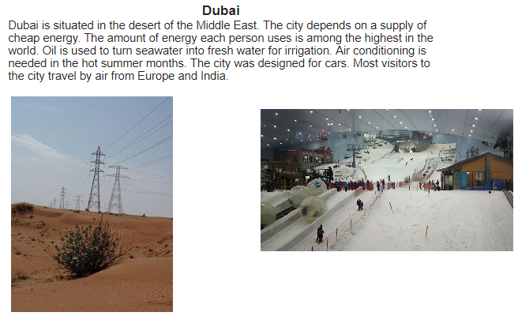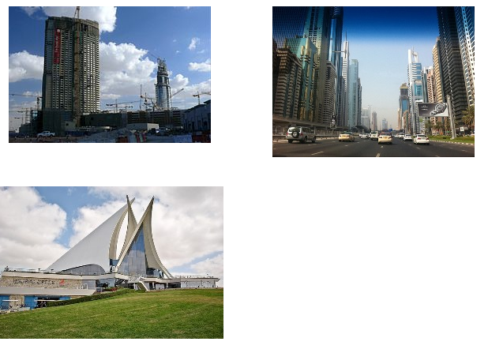

**Figure 2**

