|  |  |  |  |  |
| --- | --- | --- | --- | --- |
| The Living World Page 6 | | | | |
| Question | A B C | | | |
| 1. Define an ecosystem. | | An ecosystem is a natural system made up of only living components. | An ecosystem is a natural system made up of plants, animals and their natural surroundings. | An ecosystem is a natural system made up of plants, animals and the environment.. |
| 1. Define biome. | | A small ecosystem such as a pond or hedgerow. | A large scale ecosystem such as a desert or rainforest. | A large scale non-living component of an ecosystem. |
| 1. Define producer. | | Organisms that feed on plants only. | Organisms that get their food from the natural environment. | Fungi and bacteria, amongst other organisms that feed on dead remains. |
| 1. List two producers in the pond ecosystem. | | Algae and prawn | Prawn and Water Weed | Water weed and Algae |
| 1. Define consumer | | Organisms that feed on the producers or other consumers. | Organisms that feed on other consumers only. | Organisms that feed on omnivores. |
| 1. What are the three types of consumers? | | Herbivores, carnivores, omnivores | Herbivores, dinosaurs and ominsaurs | Omnivores, decomposers and octivores. |
| 1. List three examples of consumers found in the pond ecosystem. | | Carp, tigers and fly | Trout, frog, kingfisher | Slug, dragonfly, algae |
| 1. Define decomposer | | Organisms that get their food from the natural environment. | Fungi and bacteria that feed on dead material. They break down dead material and recycle the nutrients back to the soil. | Organisms that feed on the producers or other consumers. |
| 1. Give an example of a decomposer. | | Fungi | Algae | Waterlily |
| 1. A food chain is…… | | A single line of linkages between producers and consumers. | A web that shows all the linkages between the producers and consumers in an ecosystem. | A complex web of interconnected relationships between consumers and decomposers with the nutrients cycle. |
| 1. Provide an example of a food chain in the pond ecosystem. | | Algae > frog >slug >snake | Algae >fly >heron >snake | Algae >fly >trout>kingfisher |
| 1. What habitats are found in the pond ecosystem? | | Water, vegetation | Water, animals and pond | Vegetation and producers |
| 1. A food web is…… | | A single web of interconnected relationships between vegetation and the natural environment. | A single line of linkages between producers and consumers. | A web that shows all the linkages between the producers and consumers in an ecosystem. |
| 1. Define nutrient cycle. | | The movement of nutrients around an ecosystem, | A web that shows all the linkages between the producers and consumers in an ecosystem. | The movement of nutrients between producers and consumers only. |
| 1. Suggest one example of how nutrients are recycled within an ecosystem. | | Dead material is decomposed, and nutrients are released into the soil which allow from decomposers and consumers to grow directly. | Dead material is decomposed, and nutrients is released into the soil. Plants take up the nutrients, who pass it to consumers. When they die, decomposers return the nutrients into the soil. | Dead material is decomposed, and nutrients is released into the vegetation. Plants take up the nutrients, who pass it to producers. When they die, decomposers return the nutrients into the consumers. |
| 1. Describe the climate in the tundra. | | Cold temperatures and little precipitation (rainfall) | Cold temperatures and lots of precipitation (rainfall) | Mild temperatures and lots of precipitation (rainfall) |
| 1. Describe the vegetation in the tundra. | | Dense vegetation, including mosses, trees and low shrubs. | Sparse vegetation, there few trees including palm trees, shrubs and mosses. | Sparse vegetation, there are few trees. Vegetation there is includes shrubs and mosses. |
| 1. What does permafrost mean? | | Defrosted ground | Permanently freeze-thawed soil | Permanently frozen ground |
| 1. Describe the climate in the savannah. | | Dry, warm with relatively high precipitation (rainfall). There are four seasons: cold, hot, dry and wet. | Dry, warm with very cold seasons with relatively low precipitation (rainfall). There are no distinct seasons. | Dry, warm with relatively low precipitation (rainfall). There are two seasons: dry and wet. |
| 1. Describe the distribution of the savannah ecosystem. | | Located between the tropic of Cancer and Capricorn. | Located along the equator. | Located 23.5° north and south of the equator. |
| 1. Describe the vegetation in the savannah. | | Grassland, with scattered mosses and shrubs. | Grassland, with a few scattered trees. | Lush forest, with dense canopies of vegetation amongst the grassland. |
| 1. Describe the climate in the deciduous forest. | | Mild with relatively high precipitation (rainfall) with four distinct seasons. | Mild and very cold, with very little precipitation (rainfall) | Warm and very wet with plenty of precipitation (rainfall) |
| 1. What happens to trees in the deciduous forest during the winter? | | They keep their pinecones all year round | They lose their leaves in the winter | They lose their conifers in the winter |
| 1. Describe the location of the tundra ecosystem. | | Found at high latitudes (above 60° north and south of the equator) | Found at mid latitudes (between 30° and 60° north and south of the equator) | Found in low latitudes locations (between 0 and 30° north and south of the equator) |

|  |
| --- |
| The Living World Page 6 |
| Question |
| 1. Define an ecosystem. |
| 1. Define biome. |
| 1. Define producer. |
| 1. List two producers in the pond ecosystem. |
| 1. Define consumer |
| 1. What are the three types of consumers? |
| 1. List three examples of consumers found in the pond ecosystem. |
| 1. Define decomposer |
| 1. Give an example of a decomposer. |
| 1. A food chain is…… |
| 1. Provide an example of a food chain in the pond ecosystem. |
| 1. What habitats are found in the pond ecosystem? |
| 1. A food web is…… |
| 1. Define nutrient cycle. |
| 1. Suggest one example of how nutrients are recycled within an ecosystem. |
| 1. Describe the climate in the tundra. |
| 1. Describe the vegetation in the tundra. |
| 1. What does permafrost mean? |
| 1. Describe the climate in the savannah. |
| 1. Describe the distribution of the savannah ecosystem. |
| 1. Describe the vegetation in the savannah. |
| 1. Describe the climate in the deciduous forest. |
| 1. What happens to trees in the deciduous forest during the winter? |
| 1. Describe the location of the tundra ecosystem. |

**THE LIVING WORLD PART 1 (page 6)**

What is an ecosystem? (2 marks)

Study Figure 1, a world map showing some large scale global ecosystems.

1. Describe the distribution of hot deserts shown on the map. (2 marks
2. Describe the distribution of tropical rainforests shown on the map. (2 marks)

Outline the difference between a food chain and a food web. (2 marks)

Study Figure 2, which shows a food chain.

1. Outline the role of the decomposers. (3 marks)
2. Drought will have an impact on the ecosystem and the food chain. Complete the following sentences: (4 marks)
3. *Drought will mean that plants…*
4. *Herbivores will be affected because…*
5. *Carnivores will be affected because…*
6. *The soil will not have as much water, so…*

Study Figure 3, which shows a food web.

1. Describe how the food web shows that the difference parts of the ecosystem are linked to each other. (3 marks)
2. Outline the likely effects on the ecosystem of a reduction in the number of insects. (2 marks)

Describe the main features of a small-scale ecosystem in the UK. (4 marks)

Explain the importance of the tree in the food web. (3 marks)

Study Figure 4, a diagram showing the nutrient cycle. Explain why the diagram shown in Figure 9 is an example of nature’s recycling system. (6 marks)

**Figure 2**

**Figure 1**

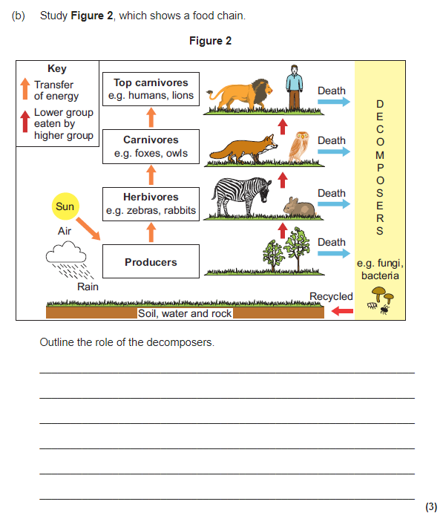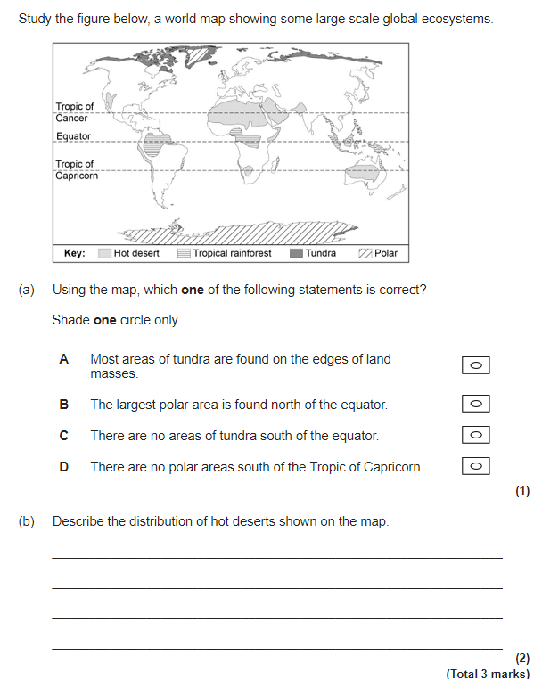

**Figure 4**

**Figure 3**

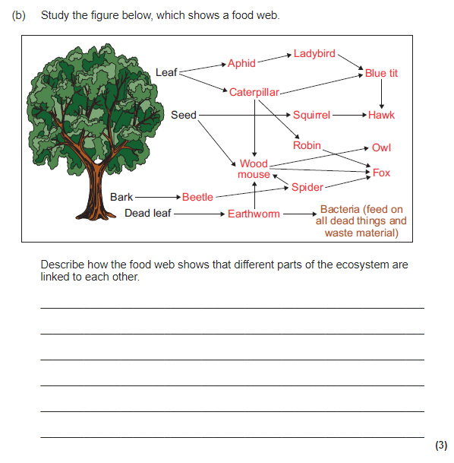

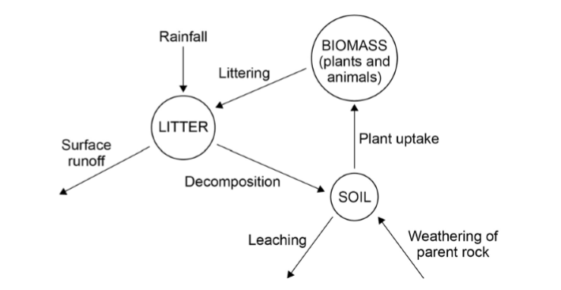

|  |  |  |  |  |
| --- | --- | --- | --- | --- |
| The Living World Page 7 | | | | |
| Question | **A B C** | | | |
| 1. Describe the location of the desert ecosystem. | | Located along the Tropic of Cancer and Tropic of Capricorn. Some extend down towards the equator | Along the equator | Between 30° and 60° north and south of the equator. |
| 1. List two examples of deserts in the world. | | Sahara, Mojave | Sahara, Nile | Congo and Sahara |
| 1. Give the temperature range of the desert  a) in the day  b) at night | | 1. Over 20°C 2. Over 20°C | 1. Over 40° C 2. Over 20°C | 1. Over 40°C 2. Under 0°C |
| 1. What is the climate in the desert known as? | | Arid | Humid | Mild |
| 1. How much rainfall is there in the desert (mm) | | Less than 25mm per year | Less than 2500mm per year | Less than 250mm per year |
| 1. Describe the soils that are found in the desert. | | Relatively fertile. | Fertile | Not very fertile |
| 1. Why are the soils in the desert not very fertile? | | There is very little plants and animals to provide recycled nutrients. | There is dense vegetation to provide recycled nutrients | There are no decomposers in the desert. |
| 1. Define biodiversity. | | The variety of organisms living in a particular area | The variety of vegetation living in a particular area | The variety of animals living in particular area. |
| 1. List one human cause of desertification. | | Afforestation | Deffirmastation | Deforestation |
| 1. List one physical cause of desertification. | | The moon’s gravitational pull | Climate change | Burning of fossil fuels |
| 1. Why are soils in the desert salty? | | Water quickly condenses = salt builds up = salty soils | Tectonic plates and continental drift means that deserts used to be under the ocean = fossils = salty soil e.g. In Arabian Desert | Water is quickly evaporated = leaves salts behind = salty soil |
| 1. Suggest one way nutrients are recycled in the desert ecosystem. | | Animals spread nutrients through their dung (poo) | Consumers decompose the nutrients in producers when they die. | Animals spread nutrients through drinking water |
| 1. Suggest one reason why there are very few animals in the desert. | | Sparse vegetation | They are hunted | Dense Vegetation |
| 1. Identify two ways the roots of the cactus have adapted to the desert ecosystem. | | Some have deep roots to reach decomposed material under the ground, while some have shallow roots to absorb nutrients above the ground | Some have deep roots to reach water under the ground, while some have shallow roots to soak up water before they evaporate | Some have deep roots under the ground to avoid being eaten, while some have shallow roots to absorb all heat from the extreme temperatures |
| 1. Define succulent and suggest a plant that has this characteristic. | | Succulents store water in their stem, such as a Joshua Tree. | Succulents store water in their stem, such as a rubber tree. | Succulents store water in their stem, such as a cactus. |
| 1. How does the thick, waxy skin of a cactus help it survive in the desert? | | To store water | To absorb much need water and nutrients | To reduce water loss from transpiration |
| 1. Suggest one way the roots of the Joshua Tree have adapted to the desert. | | Shallow roots to soak up water before they evaporate | Deep roots to reach water deep under ground | Very few roots to reduce water loss |
| 1. Identify how their small, needle like leaves help the Joshua Tree survive. | | To reduce water loss | To ensure sunlight is absorbed for photosynthesis | To store water easily |
| 1. Why are the Joshua Tree’s leaves covered in a waxy resin? | | Avoid being eaten by predators | To avoid sun and heat damage | To avoid water loss |
| 1. What does a camel store in their hump and why? | | Water for hydration | Fats for energy | Store fats to reduce water loss |
| 1. How many rows of eye lashes does a camel have and why? | | None to reduce moisture loss | One to keep sand out | Two to keep sand out |
| 1. Why do camels have large feet? | | To run at higher speeds | To spread their weight on the sand | To keep them cool |
| 1. Why do lizards burrow in the day and emerge in the night within the desert? | | Because it is cooler | Because there is more rain | Because there is more prey |
| 1. Why do the Fennec Foxes sit very still in the shade during the day? | | To keep cool | Hide from predators | So their prey can’t see them |
| 1. What does camouflage mean? | | To stand out | To blend in | Random animal markings |
| 1. List two animals that camouflage in the desert. | | Lizard, Fennac Foxes | Fennac Foxes, Camel | Camel, Lizard |

|  |
| --- |
| The Living World Page 7 |
| Question |
| 1. Describe the location of the desert ecosystem. |
| 1. List two examples of deserts in the world. |
| 1. Give the temperature of the desert  a) in the day  b) at night |
| 1. What is the climate in the desert known as? |
| 1. How much rainfall is there in the desert (mm) |
| 1. Describe the soils that are found in the desert. |
| 1. Why are the soils in the desert not very fertile? |
| 1. Define biodiversity. |
| 1. List one human cause of desertification. |
| 1. List one physical cause of desertification. |
| 1. Why are soils in the desert salty? |
| 1. Suggest one way nutrients are recycled in the desert ecosystem. |
| 1. Suggest one reason why there are very few animals in the desert. |
| 1. Identify two ways the roots of the cactus have adapted to the desert ecosystem. |
| 1. Define succulent and suggest a plant that has this characteristic. |
| 1. How does the thick, waxy skin of a cactus help it survive in the desert? |
| 1. Suggest one way the roots of the Joshua Tree have adapted to the desert. |
| 1. Identify how their small, needle like leaves help the Joshua Tree survive. |
| 1. Why are the Joshua Tree’s leaves covered in a waxy resin? |
| 1. What does a camel store in their hump and why? |
| 1. How many rows of eye lashes does a camel have and why? |
| 1. Why do camels have large feet? |
| 1. Why do lizards burrow in the day and emerge in the night within the desert? |
| 1. Why do the Fennec Foxes sit very still in the shade during the day? |
| 1. What does camouflage mean? |
| 1. List two animals that camouflage in the desert. |

**THE LIVING WORLD PART 2 (page 7)**

Explain why the climate in the deserts is arid. (3 marks)

Describe the characteristics of the soils found in the desert. (3 marks)

Study Figure 1, a photograph from the Mojave Desert. Describe and explain how vegetation in hot deserts adapts to the climate. (6 marks)

Figure 2 shows some of the world’s hot desert areas and factors affecting rainfall in hot desert areas.

1. Which lines of latitude shown in the figure, pass through the world’s hot desert areas? (1 mark)
2. Describe the global distribution of hot deserts. (3 marks)

Using examples, describe and explain how animals adapt to the desert. (6 marks)

Why are desert soils often salty? (4 marks)

**Figure 1**

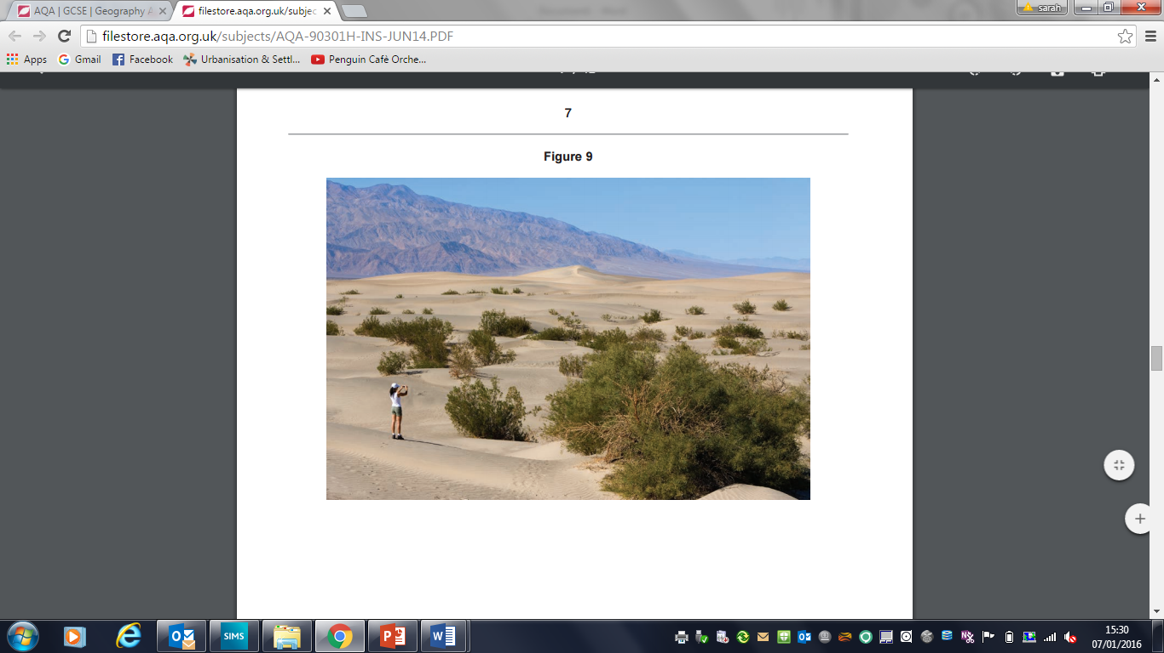

**Figure 2**

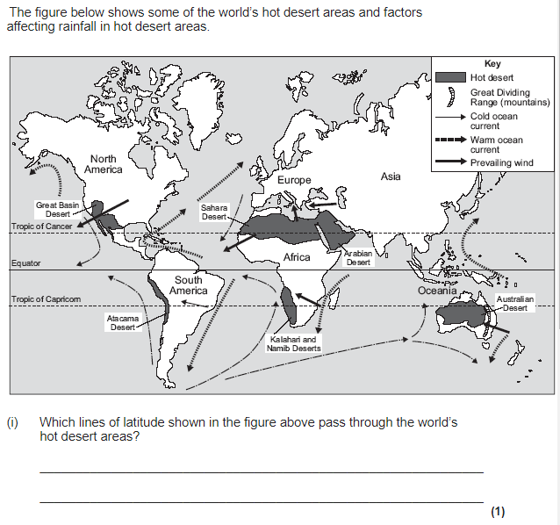

|  |  |  |  |  |
| --- | --- | --- | --- | --- |
| The Living World Page 8 | | | | |
| Question | A B C | | | |
| 1. Define economic use. | | To generate money | To improve people’s lives | To maintain the environment |
| 1. List two economic uses of the desert? | | Mining, Tourism | Tourism, Animal conservation | Solar Panels, habitat conservation |
| 1. Name the oil field in Algeria. | | Nassia Hussien | Moeen Ali-Mashood | Hassi Messaoud |
| 1. How much of Algeria’s GPD comes from oil and gas? | | 1/4 | 1/3 | 1/2 |
| 1. How many people are employed in the oilfield in Algeria? | | 40,000 | 4,000 | 400,000 |
| 1. Suggest one challenge the oilfield in the Sahara Desert faces. | | Difficult to drill for oil and gas in the dry soil | Difficult to get people to agree to work in such a remote area | Difficult to fly water and food resources to workers |
| 1. Why is solar energy generated in the Sahara Desert? | | There are 12+ hours of sunlight a day | There are 18+ hours of sunlight a day | There is sunlight 24/7 |
| 1. Where is there a solar farm in the Sahara Desert? | | Algeria | Chad | Sudan |
| 1. How has this solar farm benefitted the people? | | Easy to maintain | Easy to use and install | Money for development from exported energy |
| 1. How much water is needed to clean the solar panels daily? | | 10,300 gallons | 100,300 litres | 100,300 gallons |
| 1. Why is there a need for widespread agriculture in Egypt? | | Their population has increased from 20 million to 79 million in the last 25 years. | Their population has increased from 50 million to 79 million in the last 25 years. | Their population has increased from 60 million to 79 million in the last 25 years. |
| 1. What do they use to irrigate the fields in Egypt? | | The River Nile’s sediment | The River Nile’s water | The River Nile’s delta |
| 1. What economic opportunities does agriculture in Egypt bring? | | Accounts for 33% of the national income | Accounts for 23% of the national income | Accounts for 13% of the national income |
| 1. How does agriculture in Egypt result in salinity/salinsation (salty soils)? | | Acidic water can mean there is too much salt = salinity | Rapid evaporation of irrigation water leaves salt crystals = salinity | Poor irrigation techniques mean too much water is used = salinity |
| 1. Why do tourists visit the Sahara? | | For Arabic culture such as the Sahara Temples | Arid remote deserts are great for sunbathing | For Egyptian culture such as the pyramids |
| 1. Suggest how improved transport routes have economic benefits. | | This allows goods and people to be moved easily | Prevents tourists from ruining the natural habitats | Stops habitats being destroyed |
| 1. Tourists love to visit the Sahara. Identify two problems that they cause. | | High levels of unemployment | They use too much water. | Tourists use culture for entertainment rather than learning about traditions |
| 1. Identify two reasons it is hard to develop in the desert. | | Expensive and no natural resources | Extreme temperatures and inaccessibility | Poor water supply and not much to do for tourists |
| 1. Define desertification | | The process where land gradually turns into desert. Land becomes drier, less fertile and vulnerable to erosion | The process where water cannot be supplied to certain remote areas of land | The process where land gradually develops sand dunes |
| 1. How does over-grazing cause desertification? | | Sheep and cattle cannot live off the arid land | Sheep and cattle eat vegetation = the soil is no longer held together by plants = vulnerable to erosion | Farmers grow too many crops on the land = takes any nutrients from the land = no vegetation |
| 1. How does over-cultivation cause desertification? | | Higher populations = bigger demand for food = farmers grow too many crops on the land = takes any nutrients from the land = no vegetation = soil is exposed | Leaching from exposed soil from lack of trees means nutrients can be washed away by rain takes any nutrients from the land = no vegetation = soil is exposed | Sheep and cattle eat vegetation = the soil is no longer held together by plants = vulnerable to erosion |
| 1. Why is deforestation occurring in the desert? | | Increased demand for fuel wood | Higher tax for legal logging | Destroys natural habitats |
| 1. How does climate change cause desertification? | | CO2 is absorbed into the vegetation which kills the plants = no plants = exposed soil and vulnerable to soil erosion | More extreme weather (e.g. droughts = lack of rainfall = not enough moisture for healthy soils and vegetation to grow = vulnerable to soil erosion) | Cattle and Sheep produce methane = 3 times as harmful as CO2 which creates acid rain |
| 1. Suggest two strategies to reduce the rate of desertification. | | Grazing rotation, cracking down on corruption of government officials | Afforestation and crop rotation | Water management and afforestation |
| 1. What is crop rotation? | | When farmers allow a field to rest between farming = soil has time to repair and get nutrients back | When farmers allow their animals to move from place to place to reduce the amount of vegetation eaten or reduce the number of farm animals | Replanting trees |
| 1. What is afforestation? | | Conserving trees | Repairing trees | Replanting trees |
| 1. How does afforestation prevent desertification? | | Dead leaves decompose quicker which helps build up the nutrients cycle | Intercept moisture before it gets to the soil | The roots of plants being replanted help hold the soil together. |
| 1. What is grazing rotation? | | When farmers allow their animals to move from place to place to reduce the amount of vegetation eaten in one place. | When farmers swap those animals that graze for non-grazing breeds of livestock | Allowing cattle and sheep to only graze on alternative days |
| 1. Why is it important to use drip irrigation in or near a desert? | | One man can install and maintain the system | It’s a cheaper alternative | Helps prevent the overuse of water. |

|  |
| --- |
| The Living World Page 8 |
| Question |
| 1. Define economic use. |
| 1. List two economic uses of the desert? |
| 1. Name the oil field in Algeria. |
| 1. How much of Algeria’s GPD comes from oil and gas? |
| 1. How many people are employed in the oilfield in Algeria? |
| 1. Suggest one challenge the oilfield in the Sahara Desert faces. |
| 1. Why is solar energy generated in the Sahara Desert? |
| 1. Where is there a solar farm in the Sahara Desert? |
| 1. How has this solar farm benefitted the people? |
| 1. How much water is needed to clean the solar panels daily? |
| 1. Why is there a need for widespread agriculture in Egypt? |
| 1. What do they use to irrigate the fields in Egypt? |
| 1. What economic opportunities does agriculture in Egypt bring? |
| 1. How does agriculture in Egypt result in salinity/salinsation (salty soils)? |
| 1. Why do tourists visit the Sahara? |
| 1. Suggest how improved transport routes have economic benefits. |
| 1. Tourists love to visit the Sahara. Identify two problems that they cause. |
| 1. Identify two reasons it is hard to develop in the desert. |
| 1. Define desertification |
| 1. How does over-grazing cause desertification? |
| 1. How does over-cultivation cause desertification? |
| 1. Why is deforestation occurring in the desert? |
| 1. How does climate change cause desertification? |
| 1. Suggest two strategies to reduce the rate of desertification. |
| 1. What is crop rotation? |
| 1. What is afforestation? |
| 1. How does afforestation prevent desertification? |
| 1. What is grazing rotation? |
| 1. Why is it important to use drip irrigation in or near a desert? |

**THE LIVING WORLD PART 3 (page 8)**

Using examples, explain how the development of tourism in hot deserts can cause social and environmental damage. (6 marks)

Use a case study of a hot desert area to describe how people use the area to make a living. (6 marks)

For a hot desert environment you have studied, to what extent does that environment provide both opportunities and challenges for development? (9 marks)

Use a case study of a hot desert area to describe how people use the area for commercial farming and irrigation. (6 marks)

Study Figure 1a, a map of Dubai City showing actual and proposed tourism developments, and 1b, which shows information about tourism in Dubai, a hot desert area.

1. Describe the location of tourism areas (actual and proposed) in Dubai City shown in Figure 1a. (3 marks)
2. Use Figure 1b to provide evidence of the importance to tourism to Dubai. (3 marks)

Desertification is the process where land gradually turns into a desert. Study Figure 2, a field sketch of the land around an African village where desertification is a problem.

1. Give an example of where desertification happens. (1 mark)
2. Explain how humans and population growth has resulted in increased desertification. (6 marks)
3. Explain how areas at risk from desertification can be managed. Use the figure and your own knowledge. (6 marks)

Study Figure 2, Use Figure 2, and your own knowledge to outline causes of desertification. (6 marks)

Study Figure 3, pie charts showing the amount of desertified land and the level of desertification in three continents.

1. What percentage of the desertifed land in Asia is classed as moderate: 21%, 51% or 81%? (1 mark)
2. Describe the difference between Africa and Asia shown on the figure. (4 marks)
3. Describe two causes of desertification. (4 marks)
4. Using an example, explain how humans have tried to reduce the rate of desertification. (6 marks)

Describe how the problems caused by human activities on the edge of a hot desert environment can be reduced. (4 marks)

Use a case study of a hot desert area to describe how people try to manage the area in a sustainable way. (9 marks)

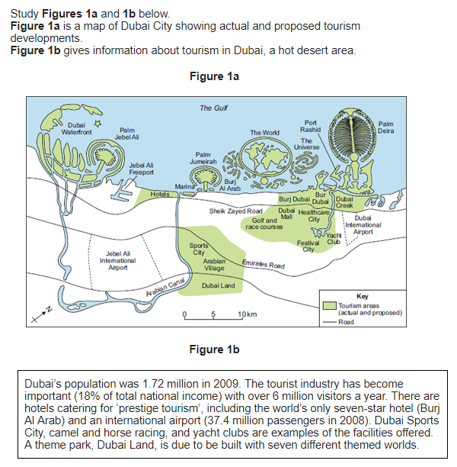

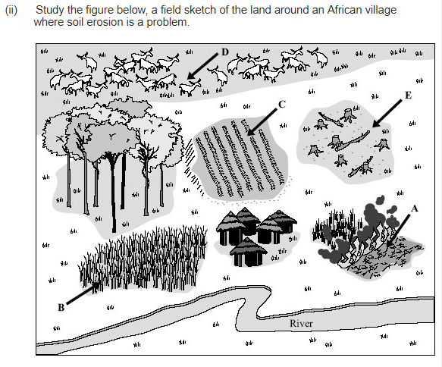

**Figure 1**

**Figure 2**

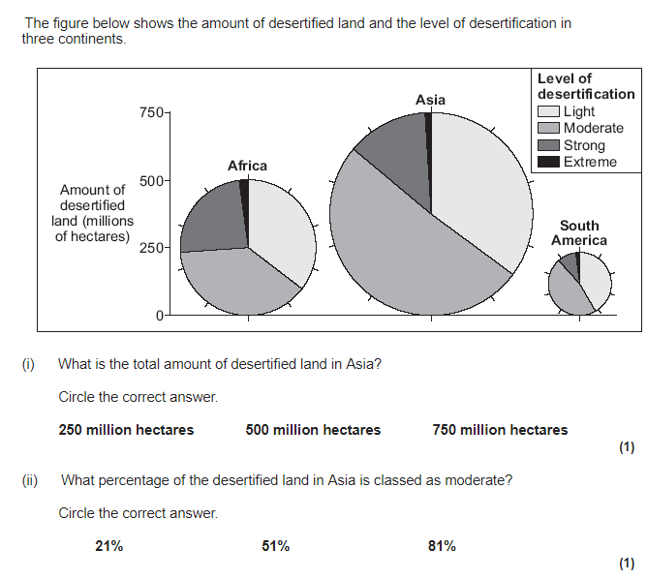

**Figure 4**

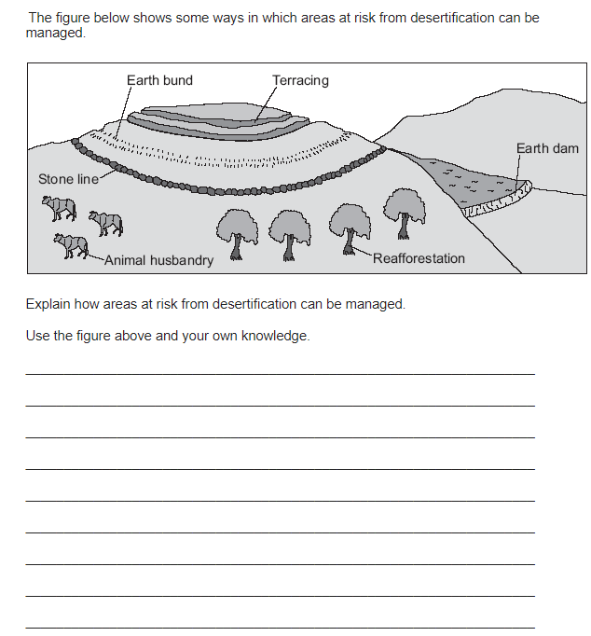

|  |  |  |  |  |
| --- | --- | --- | --- | --- |
| The Living World Page 9 | | | | |
| Question | **A B C** | | | |
| 1. Describe the location of the rainforest ecosystem. | | Between the Tropics of Cancer and Capricorn | Along the equator | North of the equator |
| 1. List two countries where you find rainforests. | | Africa and the Congo | Indonesia and the Congo | The Congo and Algeria |
| 1. What is the temperature range in the rainforest? | | 0-30°C | 10-40°C | 20- 30°C |
| 1. What is the climate in the rainforest known as? | | Hot and dry (arid) | Mild and wet (diverse) | Hot and wet (humid) |
| 1. How much rainfall is there in the rainforest (mm) per year? | | 20,000 mm | 250 mm | 2000 mm |
| 1. How many seasons are there in the rainforest? | | 2 | 0 | 4 |
| 1. Define biodiversity. | | Is the variety of organisms living in a particular area | Is the variety of vegetation in a particular area | Is the variety of animals in a particular area |
| 1. Why are the soils in the rainforest not very fertile? | | Heavy rainfall washes away most of the nutrients. This is known as leaching. | Gentle rainfall keeps all the nutrients in the soil. | There is very little organic matter that provides nutrients to the soil. |
| 1. How much of the world’s plant and animal species are found in the rainforest? | | 40% | 30% | 50% |
| 1. Why is the top layer of soils in the rainforest very fertile? | | Lots of sunlight | Lots of fresh water | Fresh leaves that decay quickly provide nutrients |
| 1. Suggest one reason why there is so much precipitation in the rainforest. | | High levels of transpiration from the trees that condense and create rain clouds | It is normally mountainous and hilly which means higher levels of convectional rainfall | The water cycle is rarely broken by human interference |
| 1. *The vegetation in the rainforest is found in …......distinct layers.* | | 3 | 4 | 5 |
| 1. Why do trees in the emergent layer grow to 40m tall? | | High levels of nutrients | Little competition from other vegetation | In order to reach the sunlight |
| 1. What is the name of the vines that grow up tree trunks? | | Lianas | Llanellis | Lionels |
| 1. Why do trees have buttress roots? | | To absorb more water | To support tall trees | To absorb more nutrients |
| 1. How does vegetation adapt in the shrub and ground layer? | | Large leaves to absorb as such sunlight as possible. | Small leaves to absorb better quality sunlight | Large leaves to blend in with their environment |
| 1. What does evergreen mean? | | A plant is a particular colour | A plant that only sheds it leaves in the winter months | A plant that doesn’t shed its leaves |
| 1. How has the red-eyed tree frog adapted to survive in the rainforest? | | See in the dark of the under canopy | Extra-long tongues to capture flies | Suction cups on its feet to help climb trees and leaves easily |
| 1. How has the spider monkey adapted to suit the upper canopy layer? | | Extra smart to be extra cunning as to avoid predators | Long, strong arms and tails so they can swing between trees | Long, strong arms to catch prey |
| 1. Suggest an animal that is able to swim in the rainforest and explain how that helps them survive. | | The blue beaver to help build a dam to help reproduce | The wart-hog due to high rainfall and many rivers | The jaguar due to high rainfall and many rivers |
| 1. Suggest an animal that is able to camouflage themselves in the rainforest. | | Leaf-tailed Gecko | Brown-river Bear | Exotic birds |

|  |
| --- |
| The Living World Page 9 |
| Question |
| 1. Describe the location of the rainforest ecosystem. |
| 1. List two countries where you find rainforests. |
| 1. What is the temperature range in the rainforest? |
| 1. What is the climate in the rainforest known as? |
| 1. How much rainfall is there in the rainforest (mm) per year? |
| 1. How many seasons are there in the rainforest? |
| 1. Define biodiversity. |
| 1. Why are the soils in the rainforest not very fertile? |
| 1. Define biodiversity. |
| 1. How much of the world’s plant and animal species are found in the rainforest? |
| 1. Why is the top layer of soils in the rainforest very fertile? |
| 1. Suggest one reason why there is so much precipitation in the rainforest. |
| 1. *The vegetation in the rainforest is found in …......distinct layers.* |
| 1. Why do trees in the emergent layer grow to 40m tall? |
| 1. What is the name of the vines that grow up tree trunks? |
| 1. Why do trees have buttress roots? |
| 1. How does vegetation adapt in the shrub and ground layer? |
| 1. What does evergreen mean? |
| 1. How has the red-eyed tree frog adapted to survive in the rainforest? |
| 1. How has the spider monkey adapted to suit the upper canopy layer? |
| 1. Suggest an animal that is able to swim in the rainforest and explain how that helps them survive. |
| 1. Suggest an animal that is able to camouflage themselves in the rainforest. |

**THE LIVING WORLD PART 4 (page 9)**

What is a tropical rainforest? (2 marks)

Study Figure 1, which shows the daily weather patterns.

1. Which of images A to D represents the weather pattern seen in Tropical Rainforests? (1 mark)
2. Using Figure 1, explain the weather found in rainforests. (4 marks)

Describe the structure and characteristics of the layers of the rainforest. (3 marks)

Study the photograph shown in Figure 2. Describe and explain the features of the vegetation shown in the photograph. (6 marks)

Study Figure 3, a photograph of a tropical rainforest. Describe the characteristics of the vegetation shown in the picture. (3 marks)

Describe and explain how animals adapt to the tropical rainforest. (6 marks)

Explain why nutrients are only found in the top layer of rainforest soils. (4 marks)

Give one reason why there is high biodiversity in the rainforest. (3 marks)

Study Figure 4, a climate graph for an area of the tropical rainforest. Describe the patterns of rainfall and temperature shown in the figure. (4 marks)

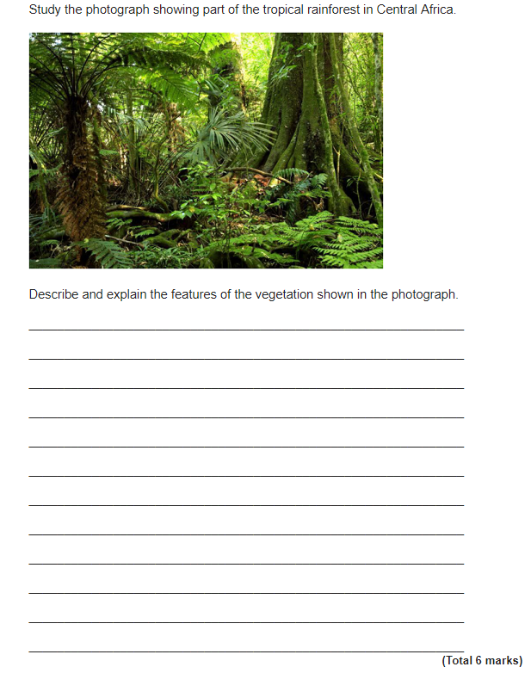

**Figure 2**

**Figure 1**

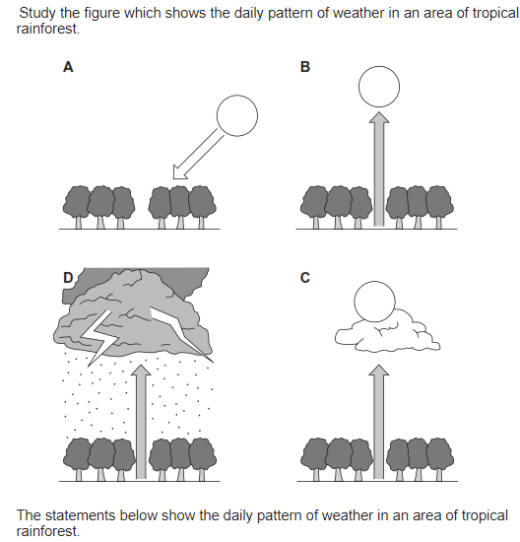

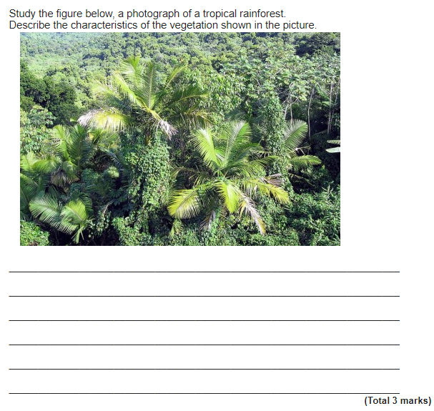

**Figure 3**

**Figure 4**

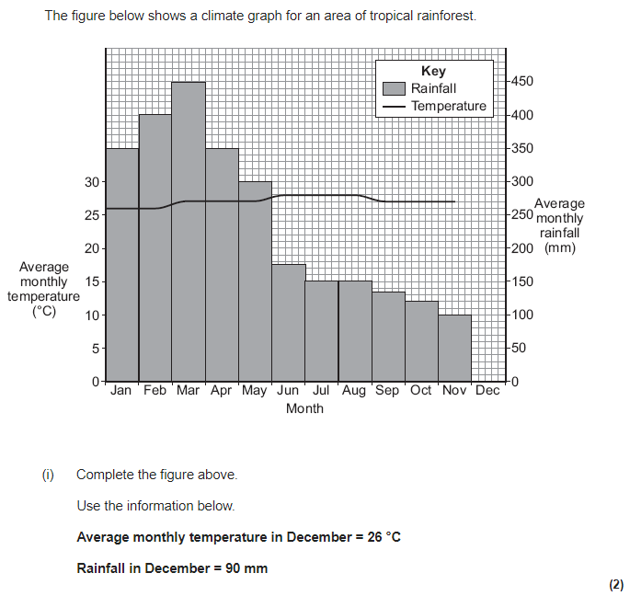

|  |  |  |  |  |
| --- | --- | --- | --- | --- |
| The Living World Page 10 | | | | |
| Question | **A B C** | | | |
| 1. Suggest two ways people use the rainforest. | | Cattle ranching, banking | Saw mills and equestrian events | Logging and hydro-electric power |
| 1. What is the name of the hydro-electric dam in the Amazon Rainforest? | | Belo-Horizonte Dam | Belo-Monte Dam | Stadio-Mayol Dam |
| 1. What is the name of the mine in the Amazon Rainforest? | | Caracus Mine | Casablanca Mine | Carajas Mine |
| 1. What is the name of a settlement in the Amazon Rainforest? | | Sao Paulo | Port-au-Prince | Manaus |
| 1. Suggest one way the Amazon Rainforest bring economic opportunity | | Jobs from the construction of dams or in mines. | Roads destroy natural habitats | Climate change allows carbon credits to be exchanged |
| 1. How much money did Brazil make from selling cattle in 2008? | | $6.1 billion | $6.9 billion | $0.69 Billion |
| 1. How does improving transport routes help the economy? | | Allows goods and people to be moved easily | Allows natural habitats to prosper | Stops corruption of government officials |
| 1. What is subsistence farming and how is it different to commercial farming? | | Local farmers produce crops to sell to generate income for their families, which is different to commercial as the profit margins are much smaller | Local farmers grow only enough food for their families to eat, unlike commercial which is to grow crops to sell for money | Local farmers use slash and burn techniques to grow crops of a better quality, unlike commercial farming the environmental impact is indifferent. |
| 1. Define deforestation. | | Planting trees | Only cutting down a certain number of trees | Cutting down trees |
| 1. How much of the Amazon Rainforest has been deforested since 1978? | | 750,000 Km2 | 7,500,000 Km2 | 75 million Km2 |
| 1. What is the biggest cause of deforestation? | | Growing of soy | Mining | Cattle ranching |
| 1. Suggest two environmental impacts of deforestation. | | Habitat loss, soil erosion | Soil transportation, unemployment | Forest conservation, commercial profit |
| 1. How has deforestation resulted in increased climate change? | | Trees remove CO2 from the atmosphere. Less trees = less CO2 removed from the atmosphere during photosynthesis. | Trees hold the soil in place to stop climate change as an impact of desertification | Plant species are lost as they are deforested. |
| 1. Define sustainability. | | Meeting the needs of the future, with only harming the needs of today | Sustaining the needs of today | Meeting the needs of today, without harming the environment in the future |
| 1. What is debt relief? | | Areas of the rainforest are subject to loans not being granted | Areas of the rainforest are given monetary value and used to repay outstanding debt | Areas of rainforest are protected through the protection of national parks. |
| 1. How does debt relief reduce deforestation? | | Countries instead of repaying loans are made to conserve rainforest. | Countries only allow debt from neighbouring countries | Countries impose sanctions if countries with rainforest don’t conserve their forest |
| 1. Why are rainforests referred to as carbon sinks? | | As trees emit CO2 | As trees absorb carbon dioxide | Trees when they decompose produce carbon |
| 1. Identify a rainforest that has been protect due to its role as a carbon sink. | | Galatia forest | Gobi forest | Gola forest |
| 1. What is selective logging? | | Picking certain areas to replant trees | Picking one in every 10 forest to cut down | Cutting down only selected trees rather than all the trees in an area |
| 1. Identify a national park that has been created in the Amazon Rainforest. How much land has been protected again deforestation? | | Tumucuwobi Forest that protects 3 million Km2 | Tumucumaque Forest that protects 38,000 Km2 | Turkmenistan Forest that protects 380,00 Km2 |
| 1. How does the FSC and Rainforest Alliance help reduce deforestation? | | They protect sustainability by allowing you to choose the forests that are cut down | They place a logo on products that have been made sustainably and therefore educates the public about different companies and products. | They ensure people only buy products from forests already cut down, so no new forests a destroyed. |
| 1. What is ecotourism? | | Tourism that use sustainable practices to reduce their impact. | Tourism that generates the maximum profit | Tourism that makes maximum profit and protects the environment as well |
| 1. Suggest two ways ecotourism is good for the environment. | | Renewable energies are used | Local people are empowered | Locals are employed. |

|  |
| --- |
| The Living World Page 10 |
| Question |
| 1. Suggest two ways people use the rainforest. |
| 1. What is the name of the hydro-electric dam in the Amazon Rainforest? |
| 1. What is the name of the mine in the Amazon Rainforest? |
| 1. What is the name of a settlement in the Amazon Rainforest? |
| 1. Suggest one way the Amazon Rainforest bring economic opportunity |
| 1. How much money did Brazil make from selling cattle in 2008? |
| 1. How does improving transport routes help the economy? |
| 1. What is subsistence farming and how is it different to commercial farming? |
| 1. Define deforestation. |
| 1. How much of the Amazon Rainforest has been deforested since 1978? |
| 1. What is the biggest cause of deforestation? |
| 1. Suggest two environmental impacts of deforestation. |
| 1. How has deforestation resulted in increased climate change? |
| 1. Define sustainability. |
| 1. What is debt relief? |
| 1. How does debt relief reduce deforestation? |
| 1. Why are rainforests referred to as carbon sinks? |
| 1. Identify a rainforest that has been protect due to its role as a carbon sink. |
| 1. What is selective logging? |
| 1. Identify a national park that has been created in the Amazon Rainforest. How much land has been protected again deforestation? |
| 1. How does the FSC and Rainforest Alliance help reduce deforestation? |
| 1. What is ecotourism? |
| 1. Suggest two ways ecotourism is good for the environment. |

**THE LIVING WORLD PART 5 (page 10)**

Study Figure 1, a graph showing the amount of deforestation in the Amazon, between 1994 – 2009 (actual) and 2010 – 2017 (targets).

1. Describe how the rate of deforestation has changed since 1995. (4 marks)
2. Explain why deforestation occurs in tropical rainforests. (6 marks)
3. Outline one possible environmental impact of deforestation. (2 marks)

Study Figure 2, a pie chart showing the causes of deforestation in the Amazon region of Brazil.

1. What is the largest cause of deforestation in the Amazon? (1 mark)
2. Suggest how use of the tropical rainforest environment can provide opportunities for economic development. Use the figure and your own knowledge. (9 marks)
3. Explain two ways in which deforestation can damage the natural environment. Use the figure and your own knowledge. (4 marks)

Study Figure 3, showing statements about deforestation that occurs in LICs.

1. *Removal of tropical rainforests must be stopped.*
2. Do you agree? Yes or No?
3. Give reasons for your choice. Use the figure and your own knowledge. (9 marks)

Explain how deforestation can negatively affect the environment.. (6 marks)

Describe the effect of deforestation on soils. (4 marks)

Suggest one way that international co-operation can help make tropical rainforests more sustainable. (2 marks)

Study Figure 4, extracts from geography textbooks about one way to reduce tropical rainforest deforestation. With the help of the extracts, explain how reducing debt can reduce tropical deforestation. (4 marks)

Study Figure 5, extracts from geography textbooks about international co-operation in managing tropical rainforests. Use the extracts and your own knowledge to explain how international co-operation can ensure that tropical rainforests are managed sustainably. (8 marks)

Describe how selective logging and replanting are examples of sustainable management in tropical rainforests. (6 marks)

The *upsei* is an efficient wood-burning stove. A UK charity has been teaching women potters in Kenya how to make them since 1987. Some of its benefits include:

1. Fewer trees have to be cut down.
2. It can be sold by the women.
3. It produces less smoke
4. It can burn crop stalks and animal dung.

Choose three advantages of the *upsei* and suggest why each is important. (6 marks)

Study Figure 6, an extract from a geographical publication about an ecolodge inn the tropical rainforest in Costa Rica, a country in Central America.

1. Explain why this lodge is attractive to ecotourists. (4 marks)
2. Describe two ways ecotourism can bring benefits to an area. (4 marks)
3. Describe how ecotouism is an example of sustainable tourism. (4 marks)

Study Figure 7, showing some methods of reducing problems in the tropical rainforest. For each method, suggest one way it might help to reduce problems in the tropical rainforest. (4 marks)

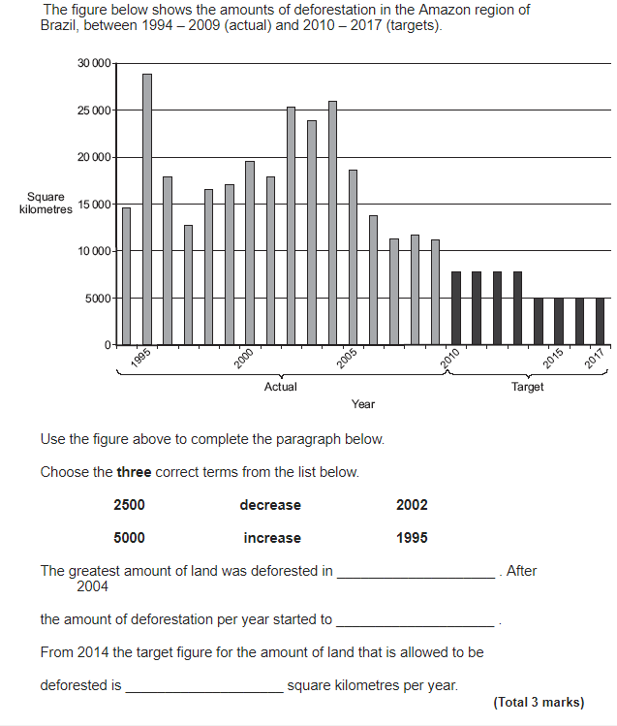

**Figure 1**

**Figure 3**

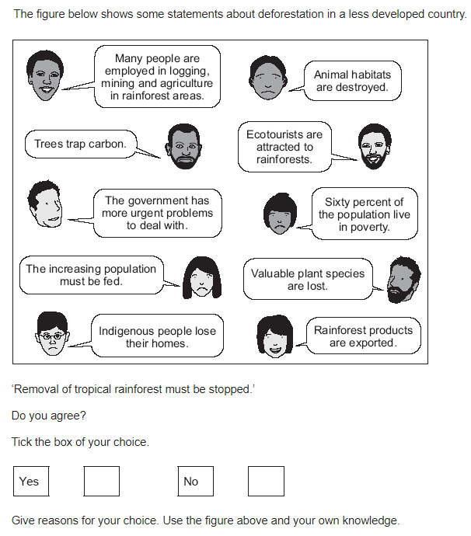

**Figure 2**

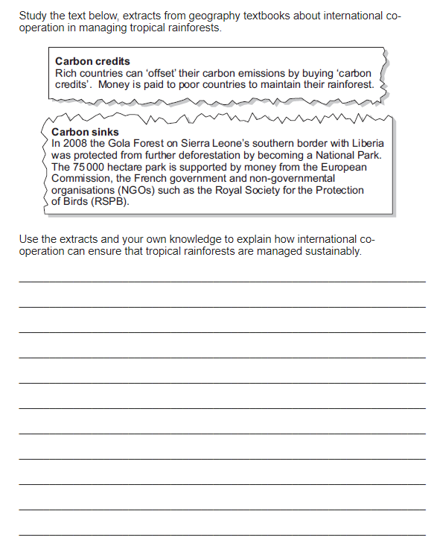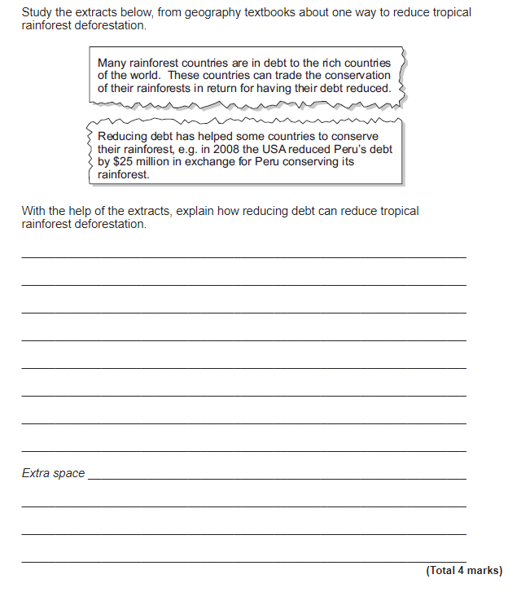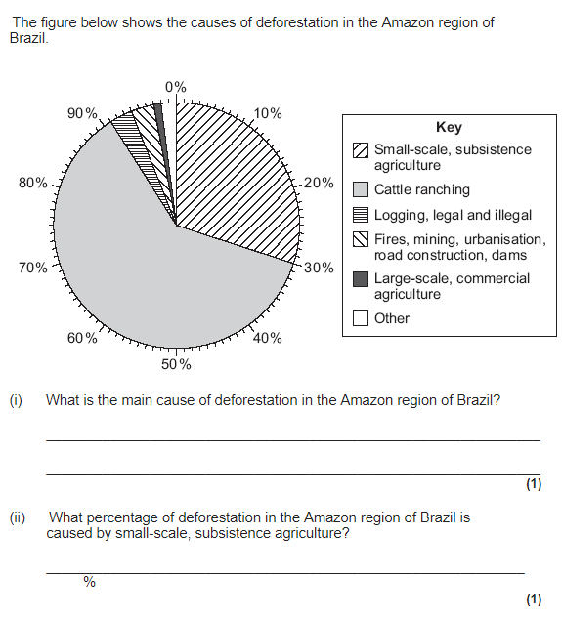

**Figure 4**

**Figure 6**

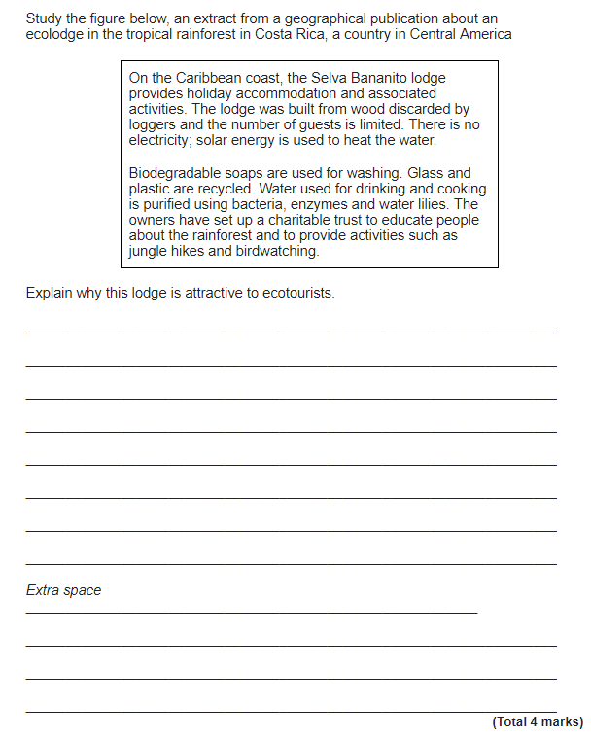

**Figure 5**

**Figure 7**

